**Micro Services**

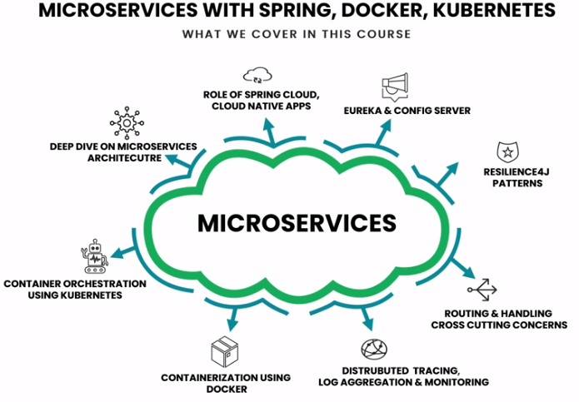

* **Micro services:** Micro services is an approach of developing single application as a suite of small services, each running its own process and communicating with lightweight mechanism (JSON, REST instead of SOAP), build around business capabilities and independently deployable by fully automated deployment machinery.

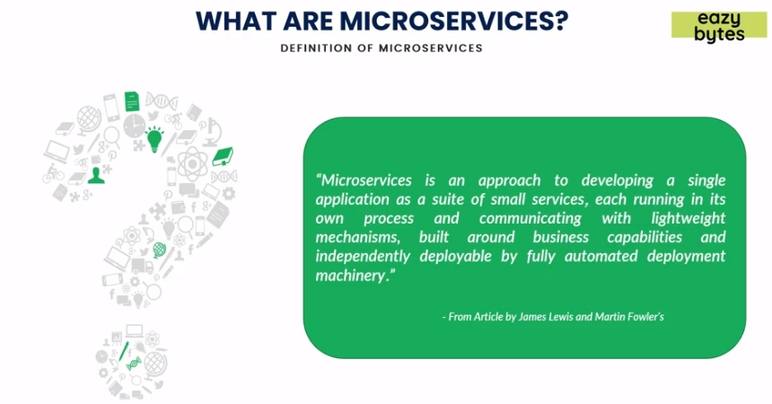

* **Architecture of Micro services:**

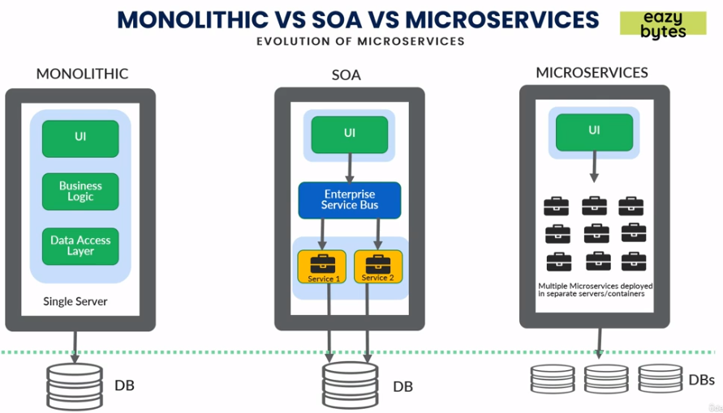

* + *Monolithic*: In monolithic architecture we had UI, Business logic, Data access layer etc deployed on a single server. It was complex as if we needed to increase nodes, then we needed to replicate same and have some load balancer between theses servers causing heavy load. Each team will checkout their code in common library like SVN or Github, from there Jenkins will club them into single package like EAR/WAR and deploy to single server (Websphere, tomcat etc)

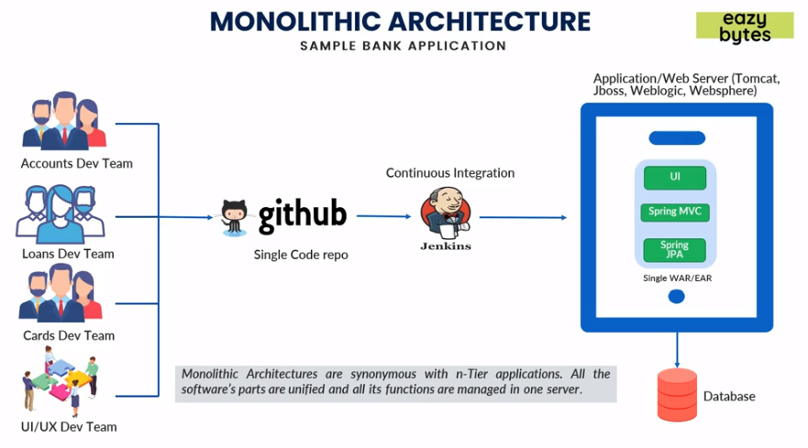

* + - *Pros*
      * Simple deployment good for smaller teams as all things are in same place.
      * Fewer cross-cutting concerns like security will be handled on a single server.
      * Better performance in terms network latency, as all things are on single server communications between layers has no latency.
    - *Cons*
      * Difficult to adapt new technologies as all layers need to be upgraded.
      * Limited agility as if we need to fix some bugs deployment will take huge time and need end to end test to make sure other features are not impacted.
      * Single code base and is difficult to maintain.
      * Not fault tolerance as if the server is impacted all services will be down.
      * Tiny updates require full deployment and impacting all other layers as well.
      * Tight coupling all layers are tightly tied together.

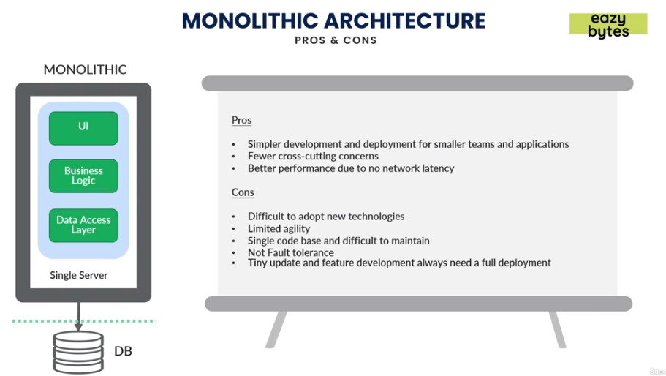

* + *SOA*: In SOA we expose or deploy the common services on different servers and UI could be on different servers and all these layers were connected using a proxy channel or Enterprise service bus. They usually follow SOAP which is restricted schema and is heavy for the business layers.

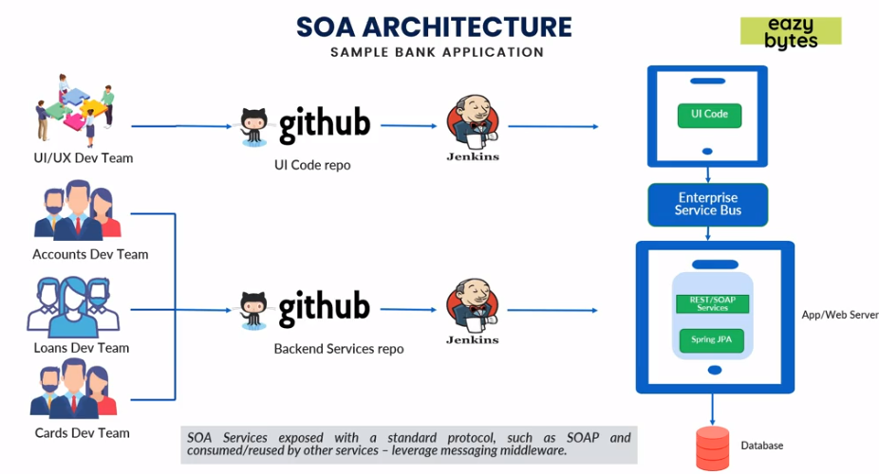

* *Pros*
  + Reusability of services as some business layers are independently deployed and can be exposed to other services as well.
  + Better maintainability compared to monolithic as some layers now are independent from each other.
  + Higher reliability.
  + Parallel development can be done now as some layers are separately deployed and tested.
* *Cons*
  + Complex management as we need different teams to manage different services.
  + High investment costs as for licensing separate components and need bigger team to manage.
  + Extra overload in managing some services.
  + Tight coupling still exists between some layers which are in single entity.

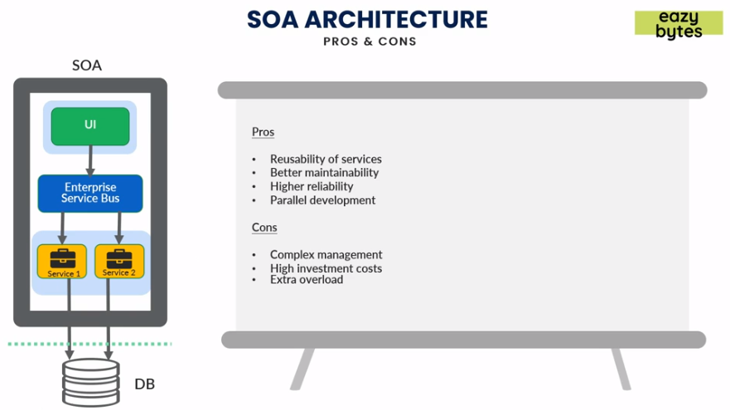

* + *Micro services*: In micro services all layers are deployed in separate containers. Each layer is independently deployed and can be worked on independently without affecting other services.

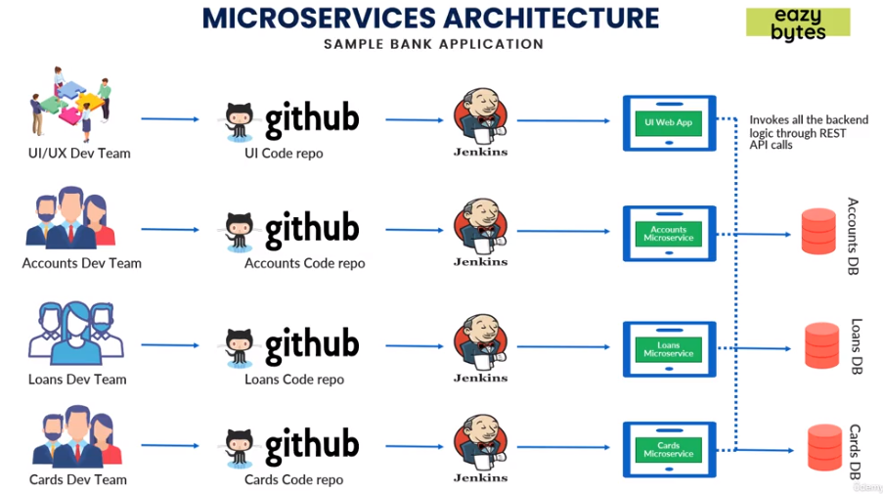

* *Pros*
  + Easy to develop, test and deploy as all layers are independent from each other.
  + Increased agility that is less downtime, faster deployment and fixing.
  + Ability to scale horizontally in case if some services requires much more compute power they can be scaled (manually or automatically) without affecting other services or downtime.
  + Parallel development can be done now as some layers are separately deployed and tested.
* *Cons*
  + Complexity as we need different teams to different services.
  + Infrastructure overhead monitoring different services and fallback mechanism like when some services is failing.
  + Security concerns as all services are now on different servers and need to be secure connection between them which is complex.
  + Loosely coupled services.

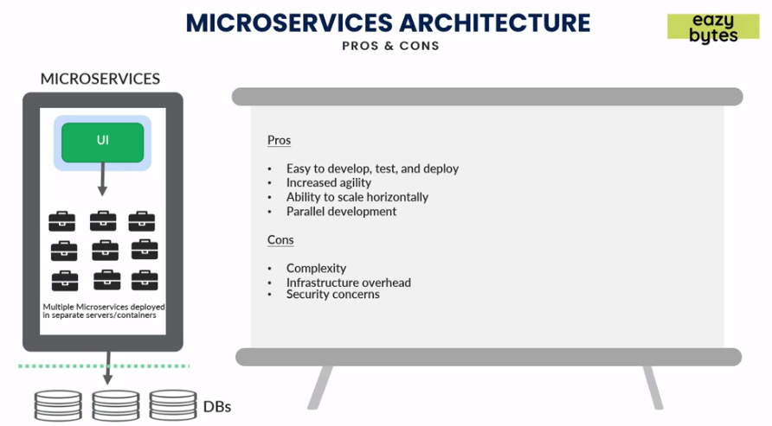

* **Monolithic vs SOA vs Micro services:** 
  + Monolithic is a *single unit*, SOA is *coarse grained* like only some services are coupled together and Micro services are *fine grained* and all services independent from each other.

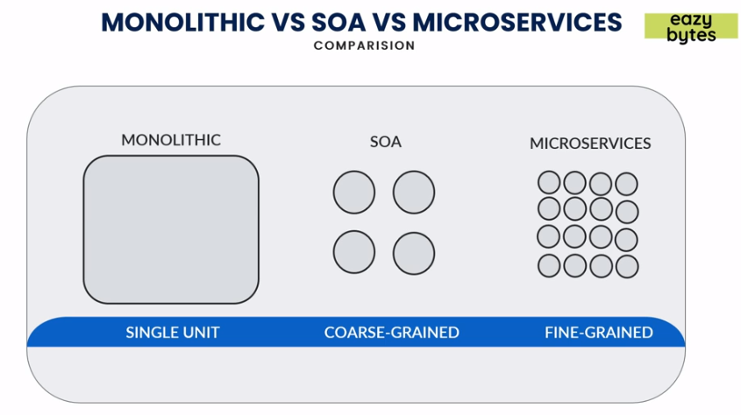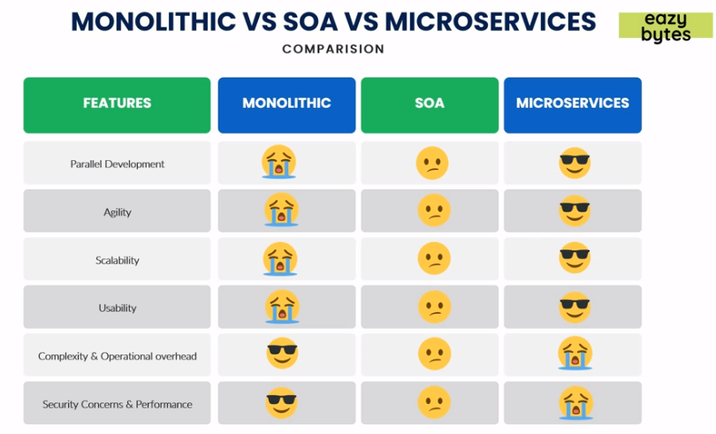

* **Why to use Spring for Micro services?**

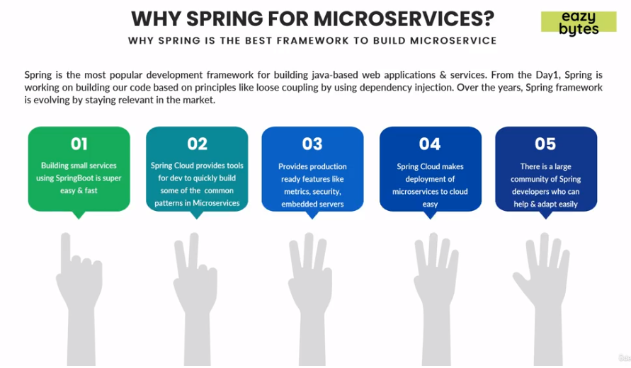

Spring is best and most popular framework for building web application and services. It has loose coupling using DI.

* + Building small services using Spring boot is easy and fast.
  + Spring cloud provides tools for dev team to quickly build micro services.
  + Provides production ready features like metrics, security, embedded servers etc.
  + Spring cloud makes easy deployment of services in cloud like GKE, Azure or AWS.
  + Spring is being used previously and lots of developers are already familiar which makes it to adapt easily.
* **Spring Boot:** Spring boot makes it easy to create stand alone, production grade Spring based applications that we can simply run.
  + *Standalone applications:* Creating standalone applications is very easy and quick.
  + *No need to deploy into server:* Embed tomcat, Jetty etc servers are available which we can deploy into directly.
  + *Starter project:*Bunch of starter projects are there for building REST, web applications etc.
  + *Auto Configuration:* Automatically configures Spring and other 3rd party libraries which are required.
  + *Production Ready Features:*With *Spring actuator* we can use inbuilt production ready features like metrics, health checks and externalizing configuration.
  + *Simple Configuration:*Provides many annotations to do simple configurations and instead of XML configuration.

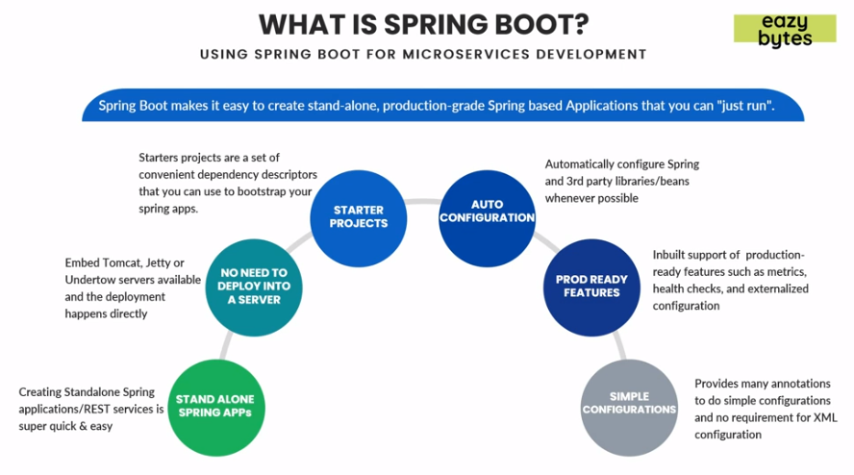

* **Spring Cloud:** Spring cloud provides tools for developers to quickly build some of the patterns of micro services.
  + *Spring cloud config:* For multiple instances of same application have a common same configuration.
  + *Service registrations and discovery:* With multiple instances being up scaled or downscaled, the services newly created will have different port or address. Through logical naming invoking them rather than the physical address.
  + *Routing and Tracing:* All calls to micro services shall pass through a single way or door before targeted services is invoked and calls will be traced to that service in case of failures.
  + *Load Balancing:* Using load balancer to efficiently distribute load (network traffic) amongst multiple backend servers or server pools.
  + *Spring Cloud Security:* Provides features like token-based security in Spring boot applications/micro services.
  + *Spring Cloud Netflix:* Netflix provided some tested Netflix components to Spring which includes Service Discovery (Eureka), Circuit Breaker (Hystrix), Intelligent routing (Zuul) and Client side load balancing (Ribbon).

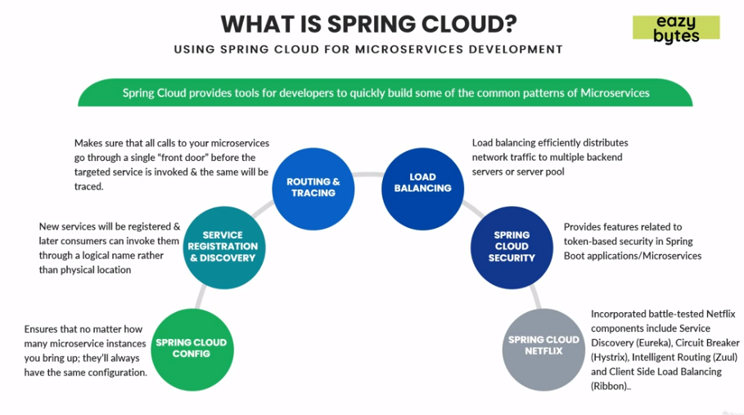

* **Challenges of micro services:** The most commonly followed approaches in the industry for identification of proper micro service boundaries and defining the size of each micro service are *Domain Driven Sizing* and *Event Storming Sizing.* 
  + *Domain Driven Sizing* is time taking process and we can size/define of micro services with Domain Driven design or business capabilities. (Based upon business features)
  + *Event Storming Sizing* is we need to conduct interactive fun sessions among various stake holders in the process of identifying micro services boundaries. (Based upon certain actions).

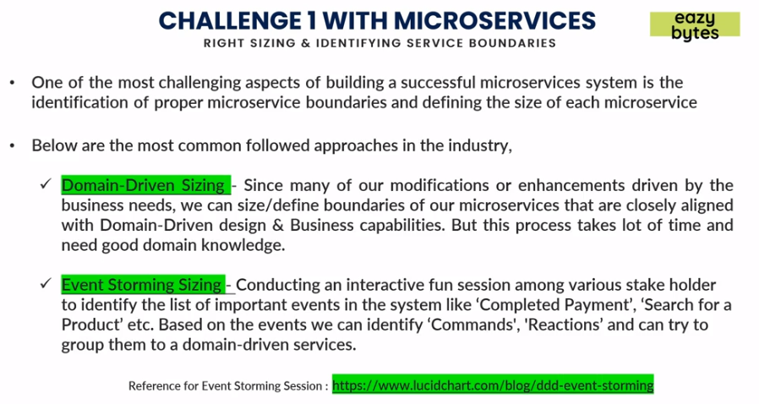

* **Right Sizing Micro services:** We need to make sure while sizing our micro service it shouldn’t be either too small or too large.

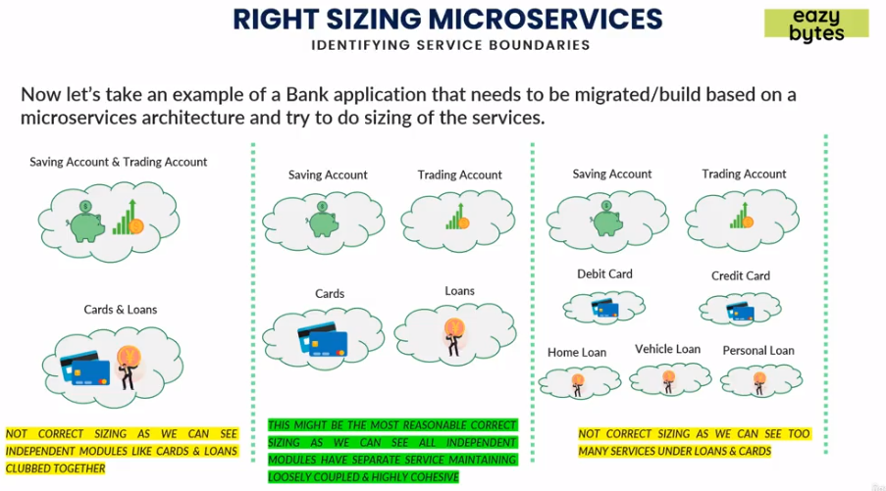

* **Monolithic architecture converted to Micro service:**

In this scenario an E-Commerce site decided to follow monolithic approach at start with small team, simple application (UI) connected with Backend process and a DB.

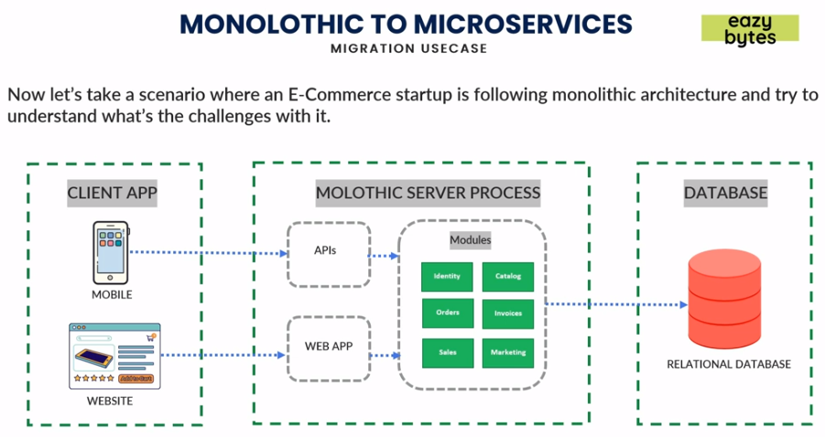

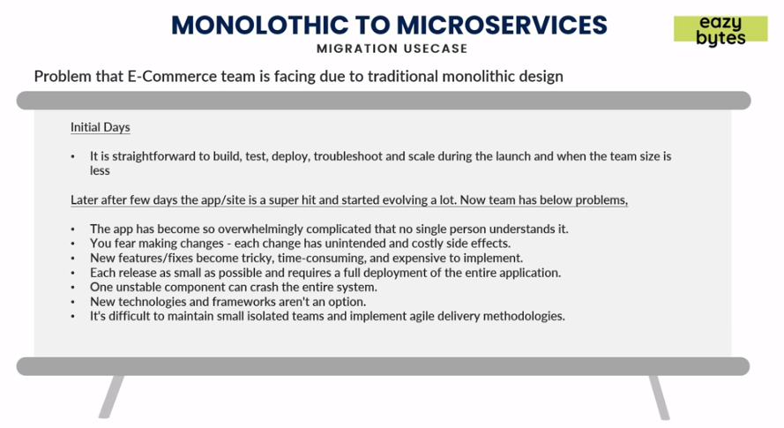

Now on later point of time they tried to switch to Micro services architecture and so they came up with keeping UI same, created a common API gateway which will connect with the services which can be connected to different Databases like RDBMS, MongoDB or Redis using JMS or event bus they send the messages and receive the messages.

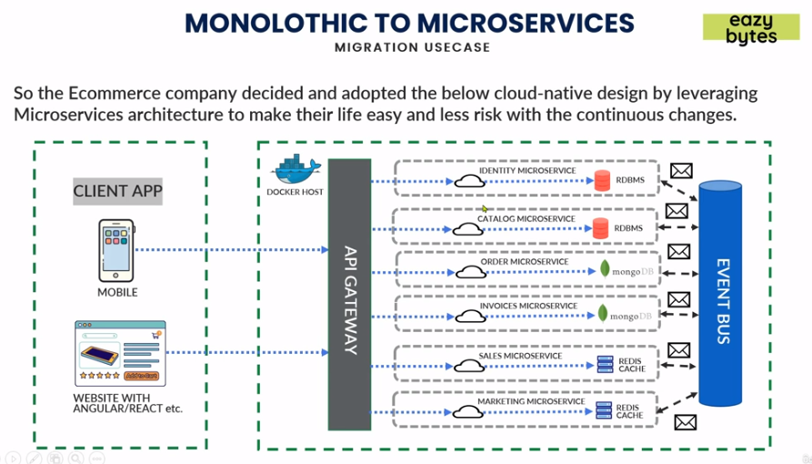

* **Installing Lombok in Eclipse:** 
  + Go to Help 🡪 Install New Software 🡪 Enter link ([*https://projectlombok.org/p2*](https://projectlombok.org/p2)).
  + Click Next 🡪 Next 🡪 Finish.
  + Restart Eclipse.
* **Docker:** Challenges with micro services if in 100s or more will be scaling, portability from one environment from other like DEV to UAT and managing deployment of these micro services can take lot of time and cost. To address this we have containerization technology like Docker helping in addressing these issues.

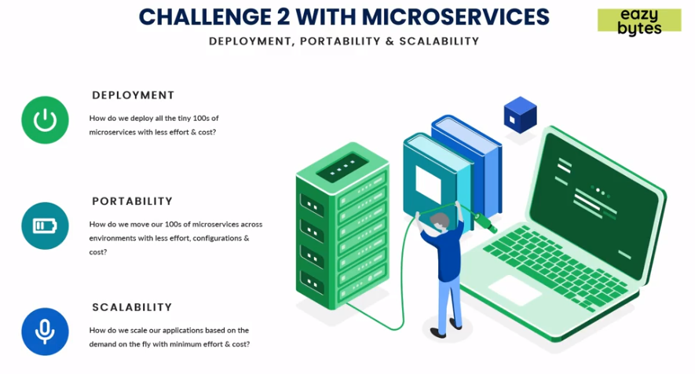

* **What is containerization?**
  + Usually in Cloud platforms like AWS, Azure, GCP etc virtual machines are allocated for each application to be deployed in cloud. *Hypervisor* is responsible for allocating the resources like how much memory, CPU for each VMs. All the VMs will have separate OS with them and it makes scaling a little bit slower when compared to Containers.
  + Containers makes deployment and scaling fast as they don’t have Guest OS instead they have a common OS and Container/Docker engine helps in allocating the resources just like Hypervisor and each micro service is isolated from each other just like VMs.

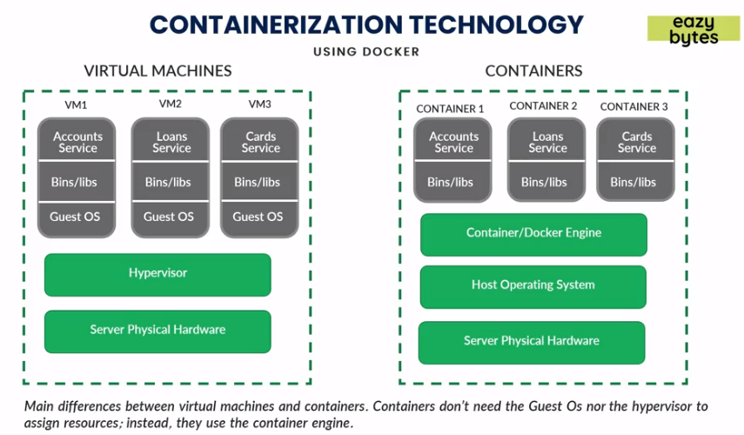

* + **Containers:** *Containers* are loosely isolated environments which contains the software and dependencies and that can be run in any computing environment (AWS, Azure, GCP). These packages are called container images.
  + **Software Containerization:** *Software containerization* is a method of OS virtualization and is used to deploy/run containers without VMs. It can run on physical hardware, Cloud, VMs etc.
  + **Docker:** *Docker* is one of the tools that use the idea of isolated resources to create a set of tools that allows application to be packages with all dependencies installed and run wherever wanted. It handles scaling, deployment portability etc.

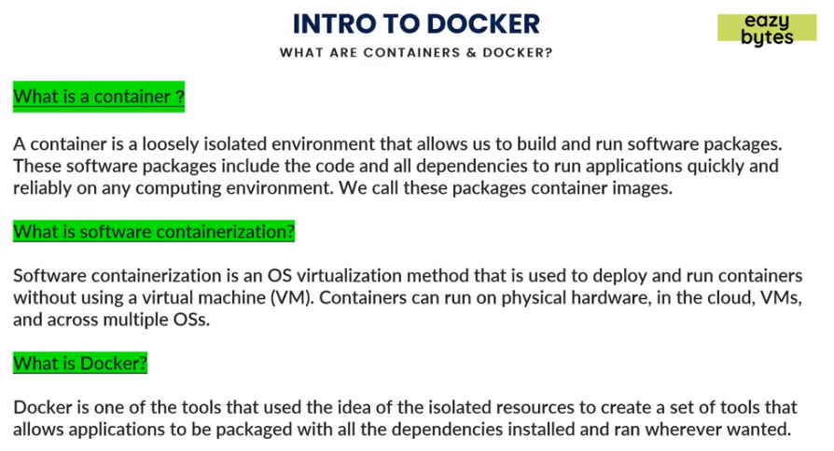

* **Docker Architecture:** 
  + *Docker Client:* We can issue commands to *Docker Daemon* using either CLIs or APIs. Just like Gitbash.
  + *Docker Host/Server:* Using *Docker Daemon* we can create and manage these Docker images. *Images* are just like java classes and *Containers* are like objects of these classes. In other words we can have multiple objects of same class just like that we can have multiple containers for a single image. *Containers are instances of images.*
  + *Docker Registry:* It is similar like to Github (repo/link) where all the Docker images are stored. Docker images can be maintained and pulled from the *Docker hub* or *Private registries.* In case if someone has Docker image they can access our Docker images and in case we need to keep it private we can do that as well using *Private registry.*

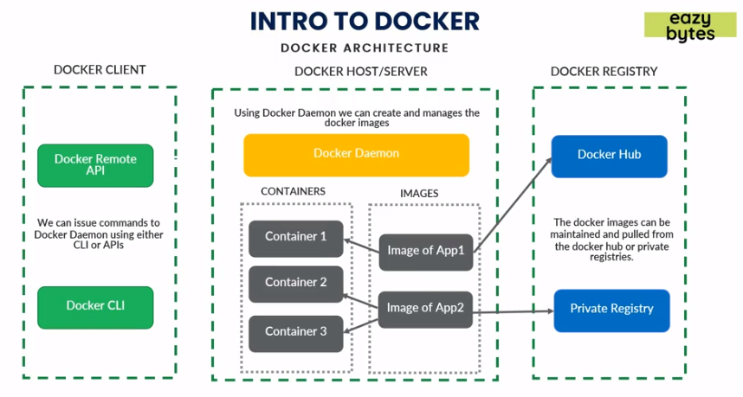

* **Steps to create a Docker image:**
  + In pom.xml we can define the type of packaging like *<packaging>jar/war</packaging>.*

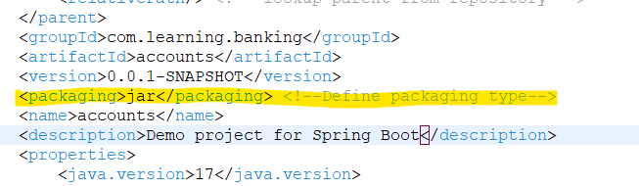

* + Do *mvn clean install* it will create a *jar/war* file in the *targets* folder.

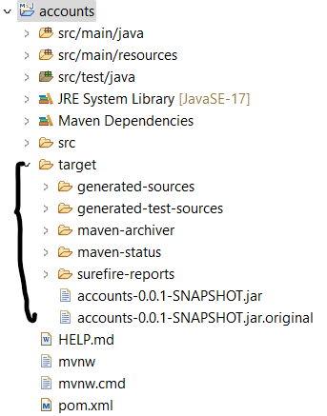

* + Running the jar file can be done with Spring command: *mvn spring-boot:run* or using Java command: *java –jar <jarName>.jar.*
  + Create a *Dockerfile* with no extension as Docker automatically reads this file.
    - *FROM <JDK_IMG> AS BUILD* 🡪 Commands will look for jdk on Docker Hub if not found will download to local.
    - *COPY target/<JAR_FILE> <FS_JAR_FILE>* 🡪 Command will copy the *target* folder jar file to container File system. Note each container will have its own File system allocated/created.
    - *ENTRYPOINT [“COMMANDS”]* 🡪Commands to run the jar file in container File system.

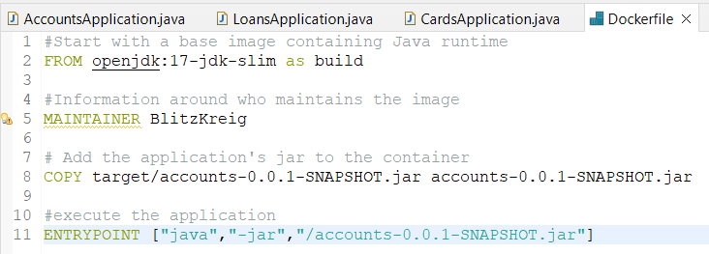

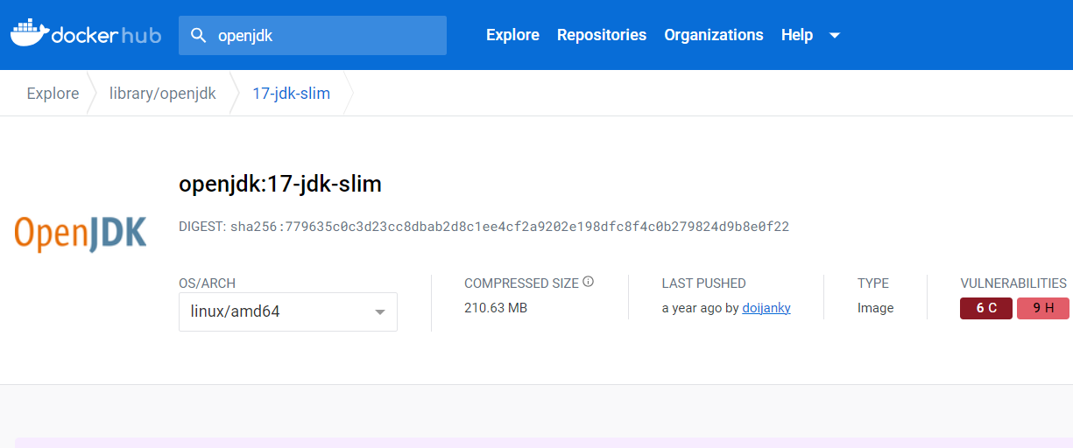

* + Open command prompt and go to the location where code is located and to create Docker Image type following command. *docker build . -t <Tag_Name>.* In the command *build* will create an image, *(****.****)* indicates that the *Dockerfile* is present in the same folder. *–t* is for creating a tag name to the image. As we can see in cmd it will look for required Docker images and download it and then execute rest of the commands. We can use *docker inspect <IMG_ID>* to get Image definition in CLI.

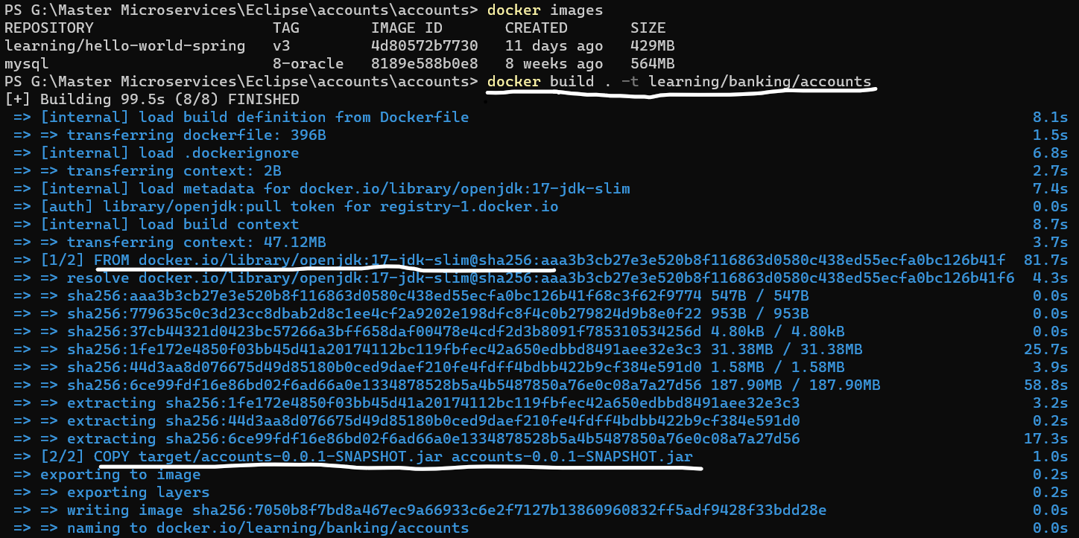

* + Run created Docker Image using *docker run –p <host_port>:<container_port> <IMG_ID>.*
    - *<host_port> 🡪* Port on which we need to expose the service, it can be different from *<container_port>.*
    - *<container_port> 🡪* Port on which the application should run inside container.

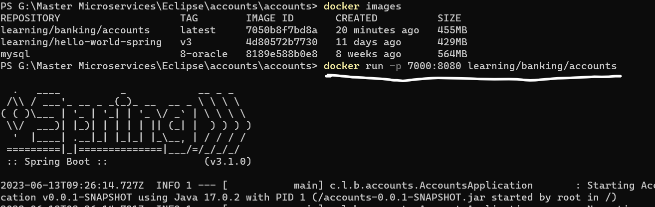

* **Important Docker commands:**
  + - *docker ps:* Shows running containers.
    - *docker logs -f <CONT_ID> 🡪* Shows logs of Docker container.
    - *docker ps –a 🡪* Shows all the container running or stopped.
    - *docker stop <CONT_ID> 🡪* Stops the Docker container.
    - *docker start <CONT_ID> 🡪* Starts the Docker container.
    - *docker container pause <CONT_ID> 🡪* Pause the Docker container, that will not accept any requests.
    - *docker container unpause <CONT_ID> 🡪* Resume the Docker container.
    - *docker kill <CONT_ID> 🡪* Instantly terminates the running Docker container.
    - *docker stats 🡪* Provides stats and metrics of running Docker container.
    - *docker rm <CONT_ID> 🡪* Removes the existing Docker container.
    - *docker run –d –p <host_port>:<container_port> <IMG_ID> 🡪* Runs Docker image in detached mode i.e., with no logs.
    - *docker push <IMG_ID> 🡪* Pushes latest Docker image to Docker hub.
    - *docker pull <IMG_ID> 🡪* Pulls Docker image to Local.
* **Build packs:** A *build pack* will transform your code into runnable application image without the need of Docker file. For Java we use *Packeto* build pack.
  + Add following configuration in the pom.xml.

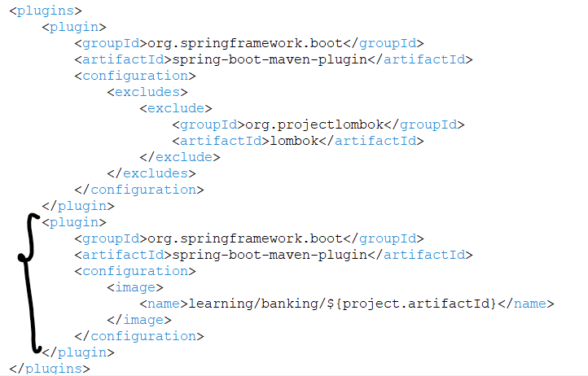

<build>

<plugins>

<plugin>

<groupId>org.springframework.boot</groupId>

<artifactId>spring-boot-maven-plugin</artifactId>

<configuration>

<image>

<name><TAG_NAME>/${project.artifactId}</name>

</image>

</configuration>

</plugin>

</plugins>

</build>

* After adding the above dependency run the following command to create a runnable image *mvn spring-boot:build-image.*
* We can make Docker repository private, we can also do that but it will be paid plan.
* Making Docker repository private 🡪 Go to Docker Hub 🡪 Go to repository 🡪 Select Image 🡪 Settings 🡪 Make private.

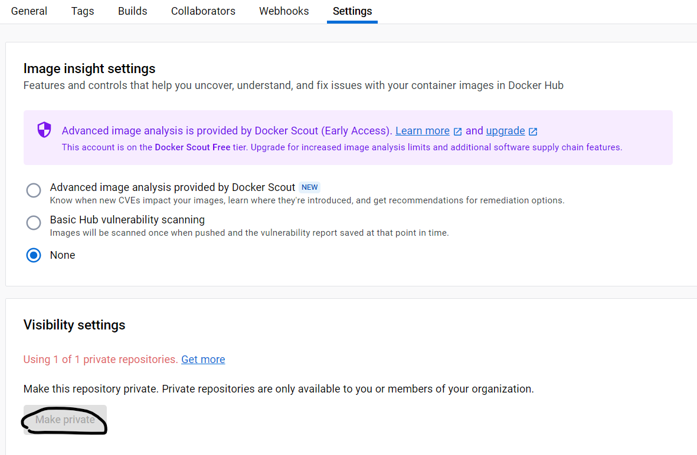

* **Docker Compose:** *Docker Compose* is a tool for defining and running multi-container Docker applications. With Compose, we need a YAML file to configure application's services. We can get version for Docker-compose yaml file from <https://docs.docker.com/compose/compose-file/compose-file-v3/>.

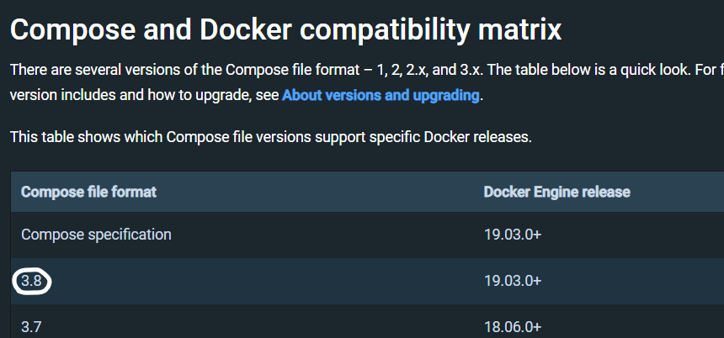 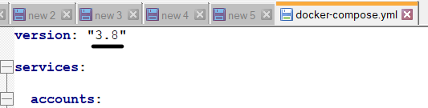

* + Files should be named as *docker-compose.yml, compose.yml, docker-compose.yaml, compose.yaml* and placed into the root folder.



* + Command to run configuration from docker-compose.yml:*docker-compose up*
  + Command to stop from docker-compose.yml:*docker-compose stop*
* **Cloud Native Applications:** It is a collection of small, independent, loosely coupled services which deliver some business values. If an application is cloud native it is designed to provide continuous development, automated management across private, public, hybrid clouds.

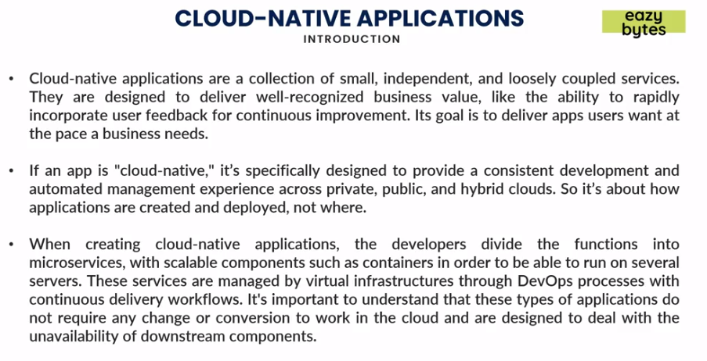

* **Principles of Cloud Native applications:** 
  + *Micro service:*Breaks applications into small components independent from each other.
  + *Containers:*Containers are packaged application with dependencies which makes it easy to move to any environment with full functionality.
  + *DevOps:* It is an approach to culture, automation and platform design intended to deliver business values.
  + *Continous Delivery:*Software development practice in which the process of delivering software is automated to allow short time deliveries.

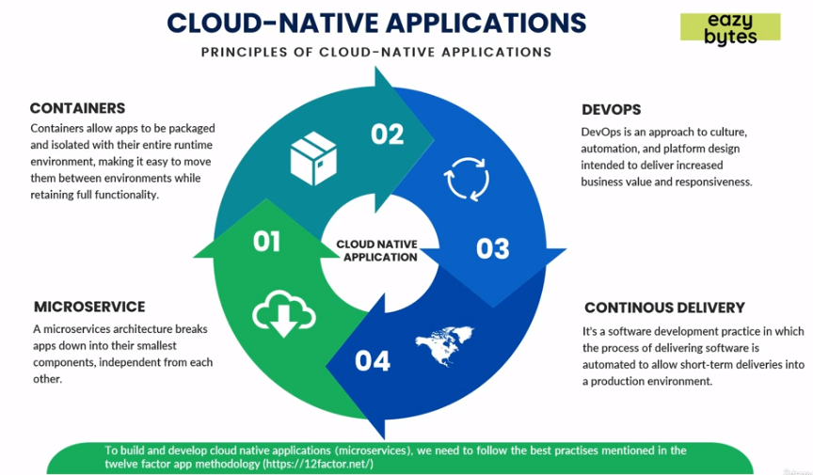

* **Difference between Cloud Native application and Traditional Application:**
  + Cloud Native applications are *predictable in behavior* which means if something or some instance goes down, it will auto manage and create new instance instead of letting whole system down.
  + Cloud Native applications are *OS abstracted*, using Docker we can deploy our applications in any OS (Win, Linux, AIX) which was not the case with traditional applications.
  + Cloud Native applications are *right sized* (number of instances based upon usage) and independent from each other.
  + Cloud Native applications implement *continuous delivery approach* i.e., development is easy and faster without bringing down whole system for deployment.
  + Cloud Native applications have *rapid recovery* as the downtime is very less and can recover automatically in case of failures in any instances.

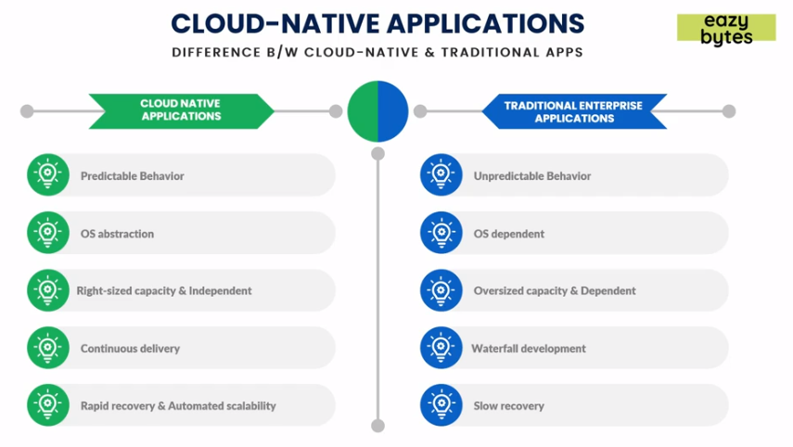

* **12 factor App:** There are 12 factors which are best practices for Cloud native application.

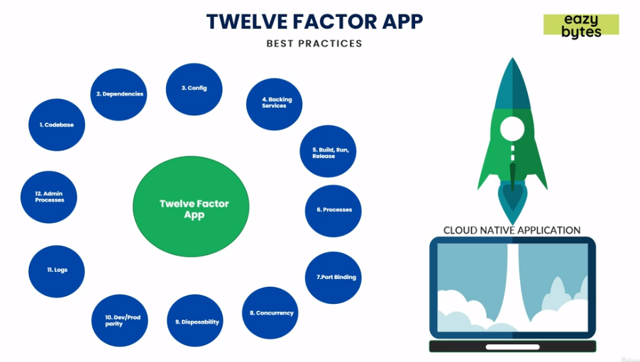

* + **Code Base:** Each micro service should have its own codebase and managed using source control like github.

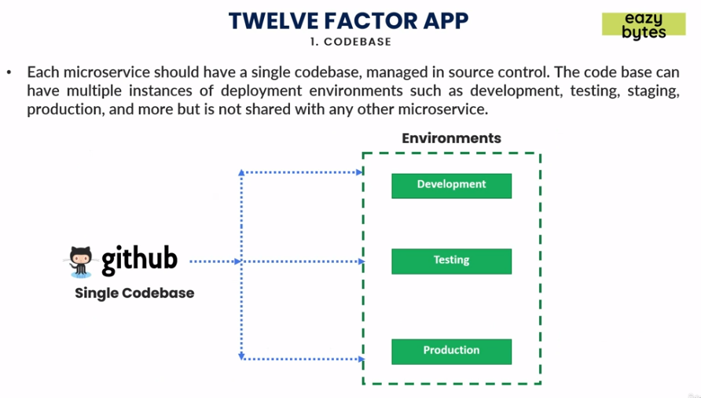

* + **Dependencies:** Dependencies should be declared using build tools such as Maven or Gradle. It should not be like we can add dependencies once Docker image is created.

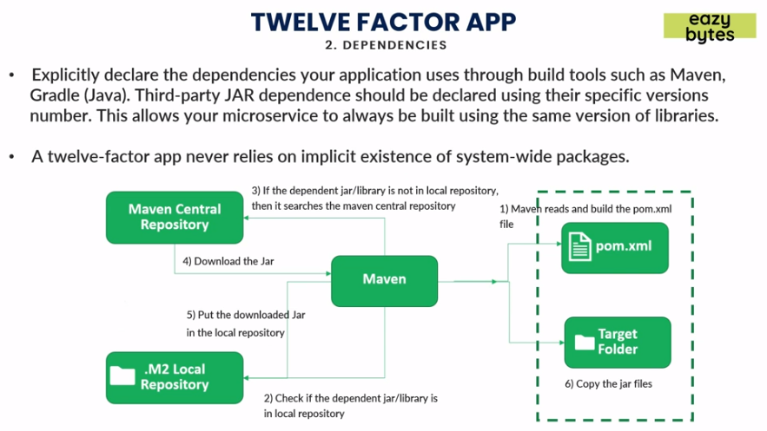

* + **Configuration:** Storing of environment specific configuration independently instead of hard coding inside the code.

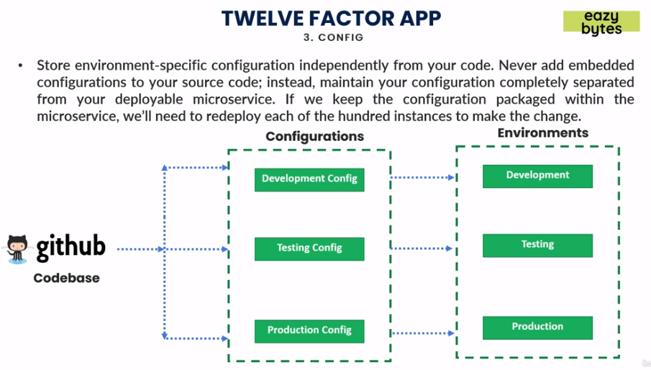

* + **Backing service:** Easy switching of connections from local to third party connections.

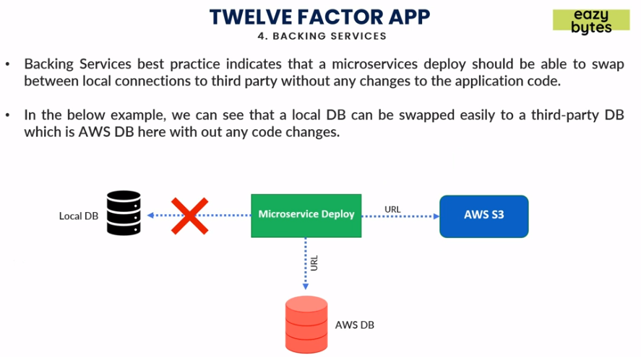

* + **Build, run and release:** Keeping build, release and run stages of deploying applications separate from each other. The process of build should not vary environment to environment.

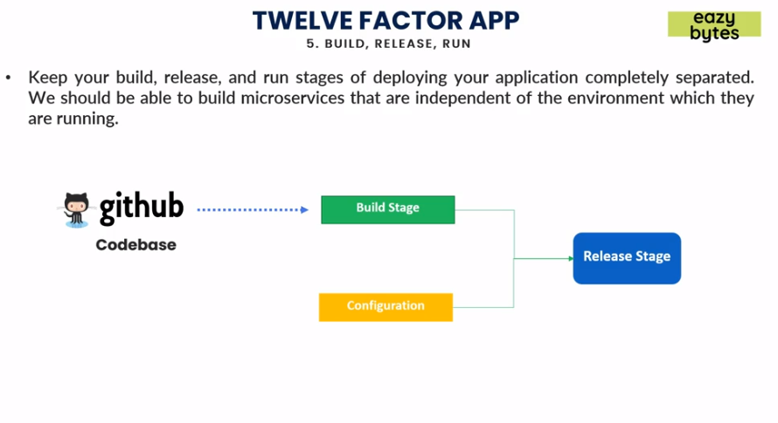

* + **Processes:** We could have multiple micro service interacting with each other and they should be stateless by mean not storing any session details or data that can be lost once if one micro service goes down impacting communication with others.

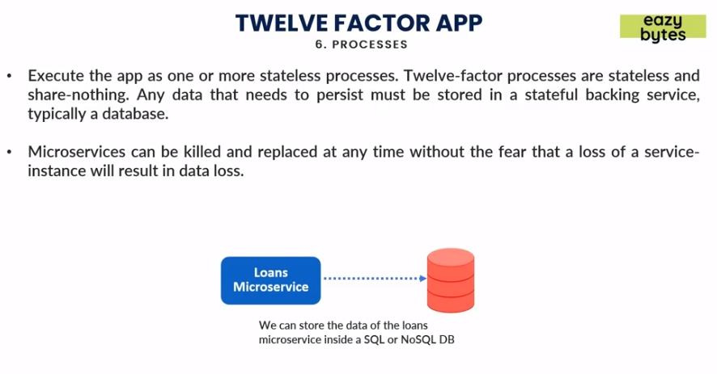

* + **Port Binding:** Ports of each micro service should not be same and have their own ports defined providing isolation.

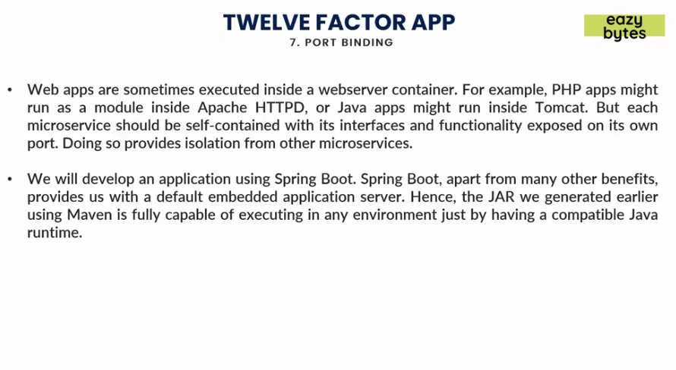

* + **Concurrency:** *Vertical Scaling* refers to increase of resources whereas *Horizontal Scaling* refers to adding more instances. The best approach recommended is *Horizontal Scaling* instead of *Vertical Scaling.*

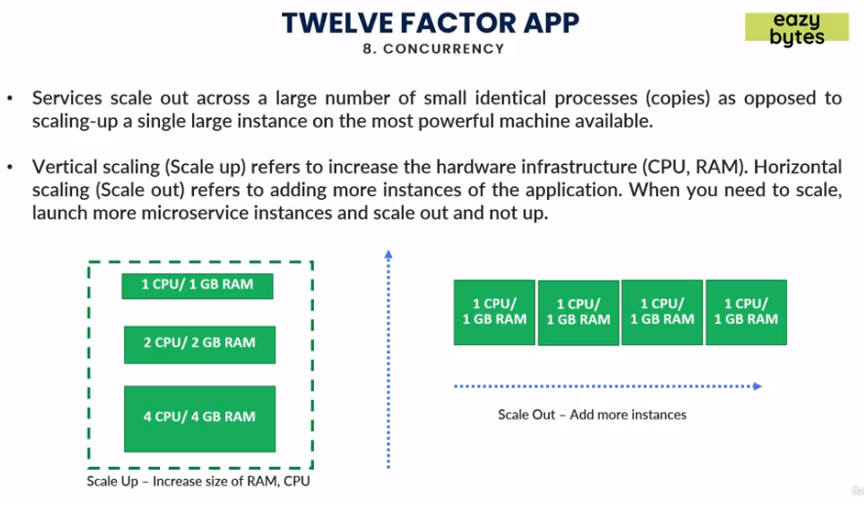

* + **Disposability:** Instances should be easy to shut down or dispose, favoring fast startups, for that we can use Orchestrations tools which can manage in the case of failure it should replace corrupt instance with new one.

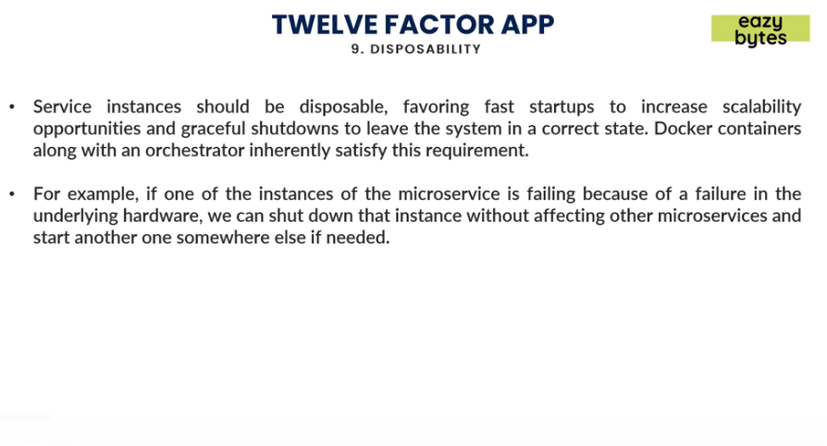

* + **Dev/Prod Parity:** Keeping all environment as similar as possible. If some code is changed and then tested it should go once promoted from Dev to all the way to production.

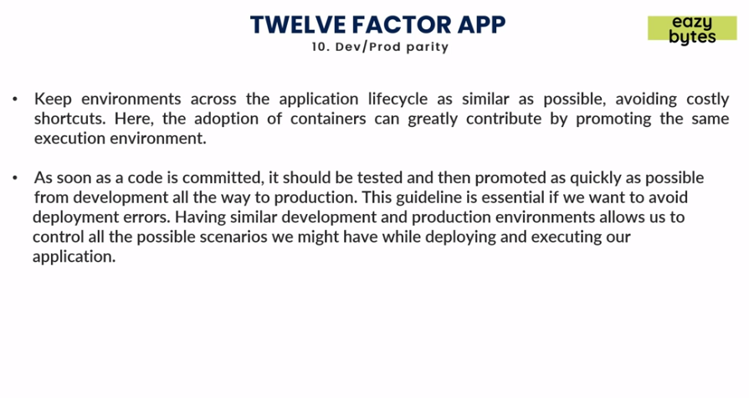

* + **Logs:** Logs should be generated as event streams and should be managed using tools such *Logstash* that will collect logs and store it in location.

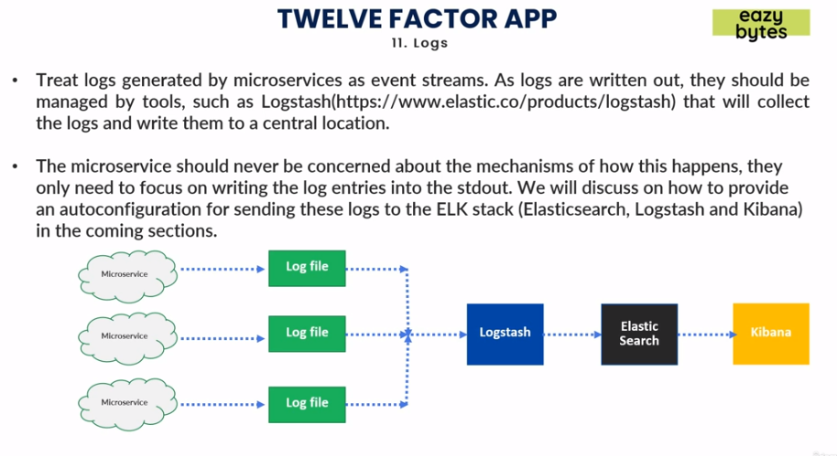

* + **Admin Processes:** Some of admin tasks like cleanup process or pulling reports should be separate from the application.

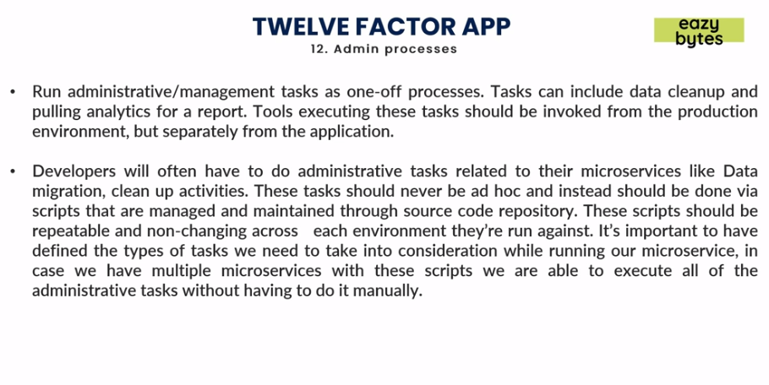

**Configuration Management:** We need to have maintain Configuration properties in a centralized system like Github/DB/File system, Inject these configuration into micro services using CMS (Configuration Management Service) and for each environment all the configurations should be separated.

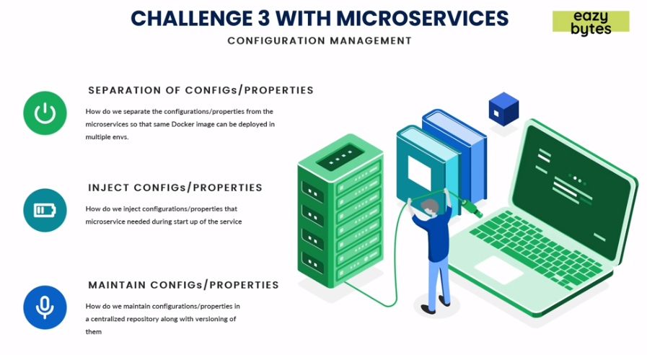

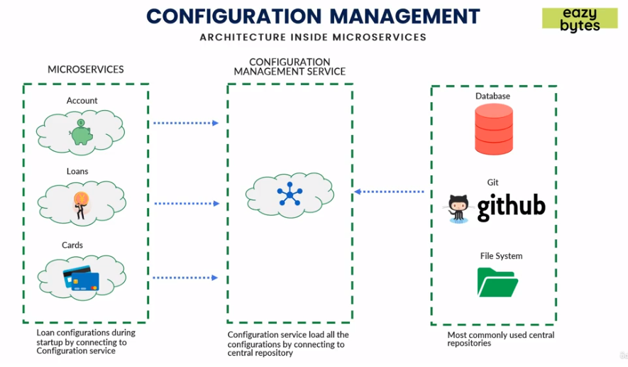

**Spring Cloud Configuration:** Spring Cloud Configuration provides server and client side support for externalized configuration, so that so Github will contain all properties CMS will manage and expose properties via APIs which can be used by micro services.

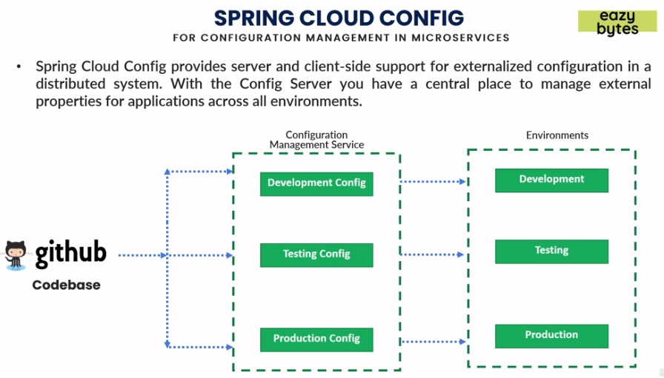

* **CMS Server features**
  + HTTP or resource-based API for external configuration.
  + Encrypt and decrypt property values.
  + Embeddable in Spring boot application using *@EnableConfigServer. '@EnableConfigServer'* annotation will make your micro service to act as a Spring Cloud Config Server.
* **CMS Client features**
  + Bind to the Config server and initialize with property sources.
  + Encrypt and decrypt property values.

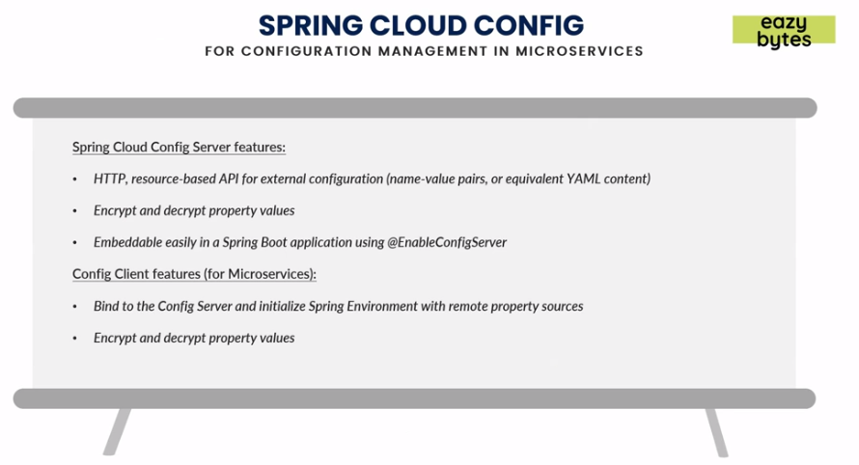

* **Creating a CMS server:**
  + Create a Spring starter project with adding dependencies for spring boot actuator and spring-cloud-config-server.
  + Enable main class with *@EnableConfigServer* annotation will make your micro service to act as a Spring Cloud Config Server.

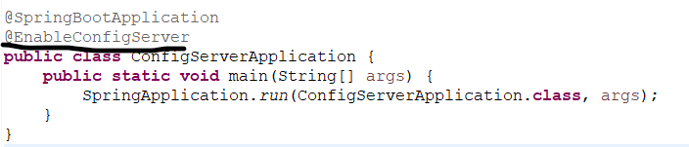

* + Add all configuration files in the *src/main/resources* folder.

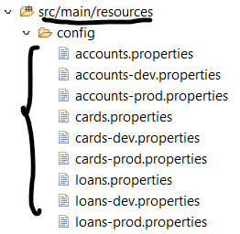

* + Add following properties in *application.properties*. Note we are using native in case the properties are stored in the project itself otherwise it will be *git* for github.

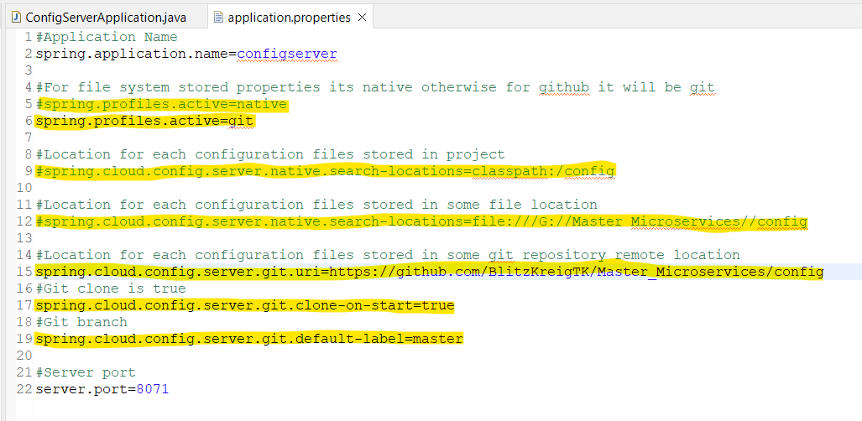

* + Run the application main class and hit the url, */default* will show the default properties only. */dev* or */prod* will have dev or prod properties followed by default properties so in case of some missing values in dev or prod they will show the value present in default properties.

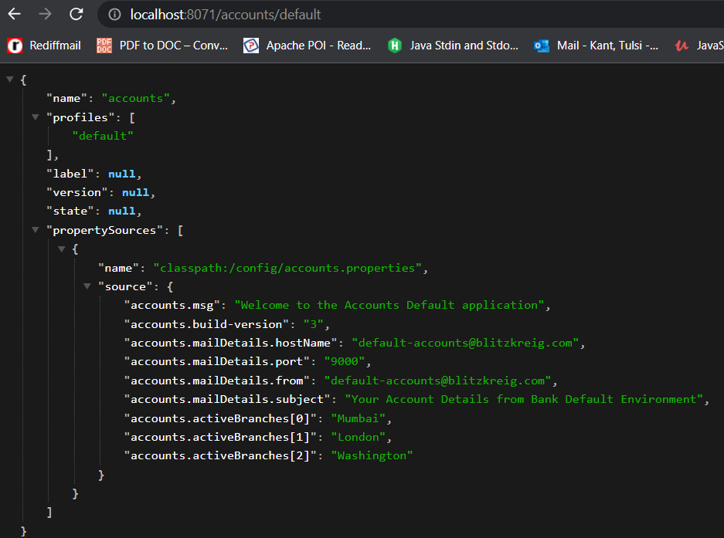

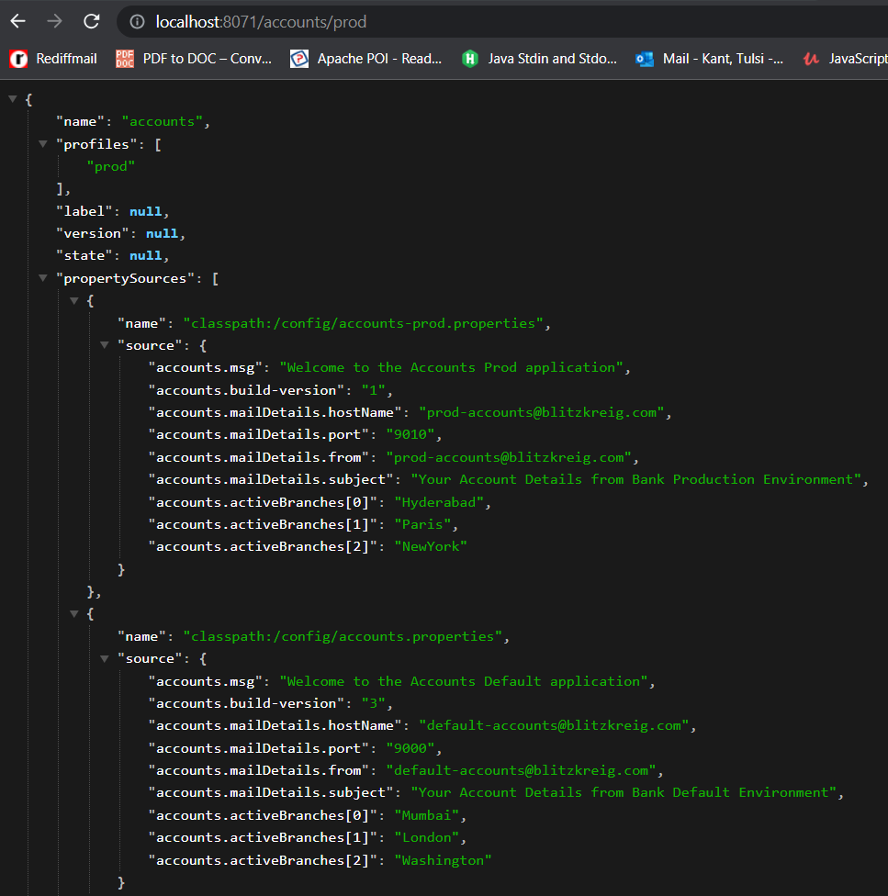 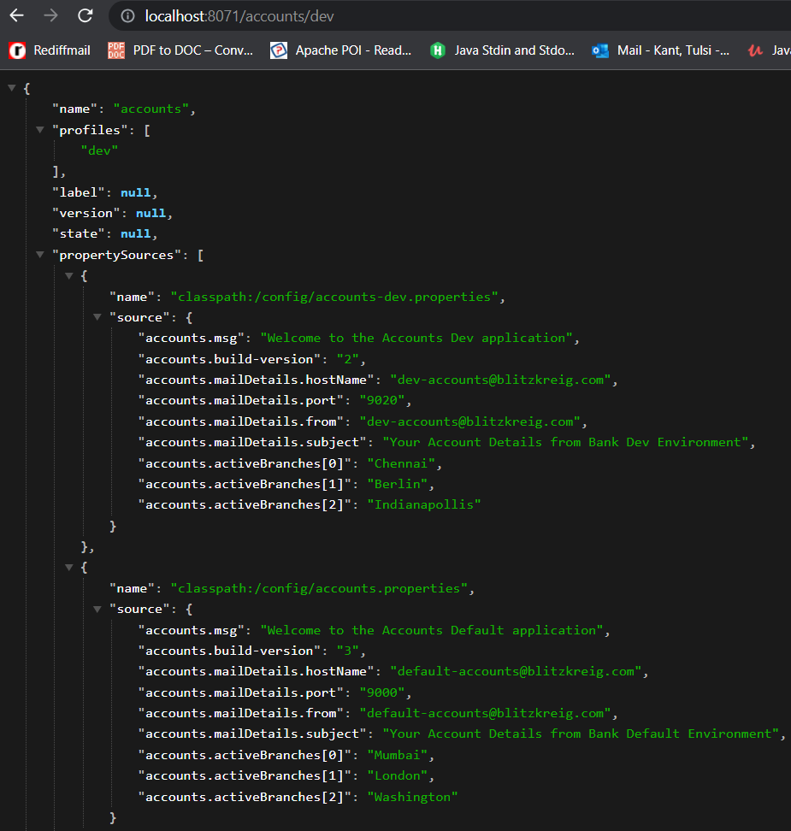

* **Read from CMS server:**
  + Add following dependency in *pom.xml* of application.

<dependency>

<groupId>org.springframework.cloud</groupId>

<artifactId>spring-cloud-starter-config</artifactId>

</dependency>

* + Create a config class to map properties from CMS server into JSON.

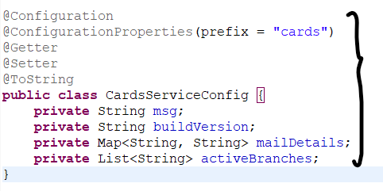

* + In *application.properties* add below properties.

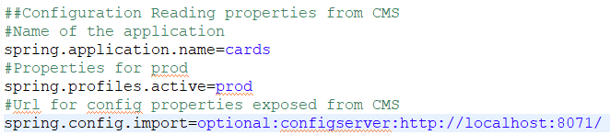

##Configuration Reading properties from CMS

#Name of the application

spring.application.name=<Application_Name>

#Properties for environment name

spring.profiles.active=<Environment_Name>

#Url for config properties exposed from CMS

spring.config.import=optional:configserver:url

* + Access properties anywhere by injecting or autowiring the config class.

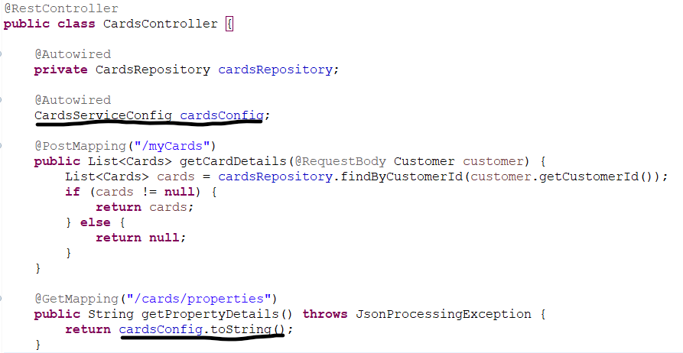

**Sample yaml to restart all Docker containers with config server service:**



**@RefreshScope:** This annotation is used to refresh the properties in application updated in configurations which will not require startup on application level. For example if we modify DB connection details in CMS it will require application to restart to take effect of new changes. We can invoke a *refresh url* by making a post call to the *actuator provided refresh url.*

* Add following properties in *application.properties.*

#To expose /refresh url by actuator

management.endpoints.web.exposure.include=*

* Add *@RefreshScope* in main class*.*

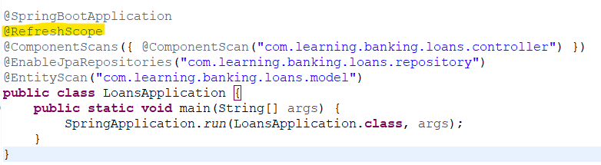

* Do a post call to the url *http://<server>:<port>/actuator/refresh* to refresh properties.

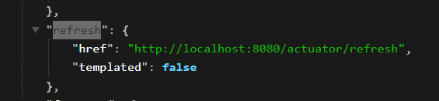

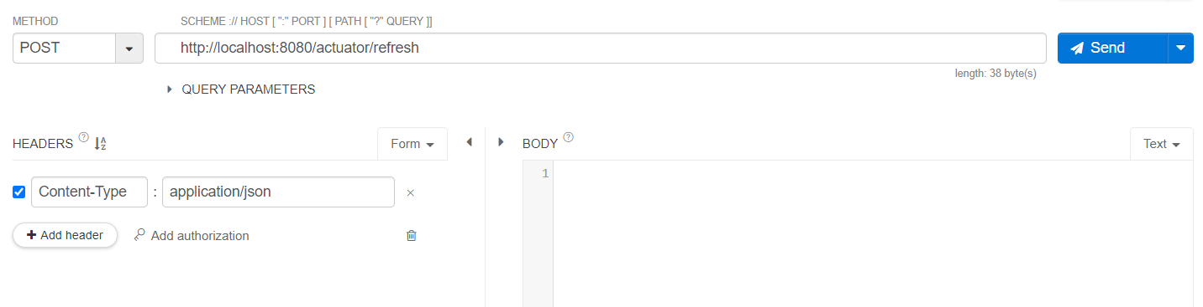

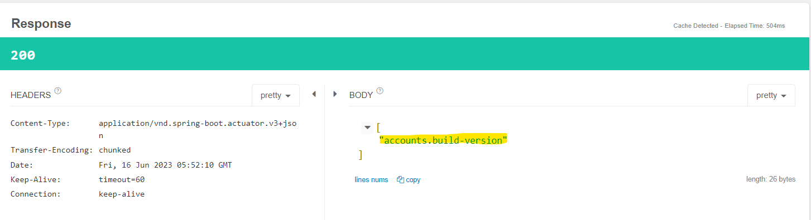

* **Encrypt/Decrypt Configuration:**
  + First add the following properties in the CMS *application.properties.*

#Encrypting key

encrypt.key=blitzkreig

* + Start CMS and do a POST call to */encrypt* url and pass text we want to encryptand in case we need to decrypt encoded value, we can do similar thing with */decrypt* url.

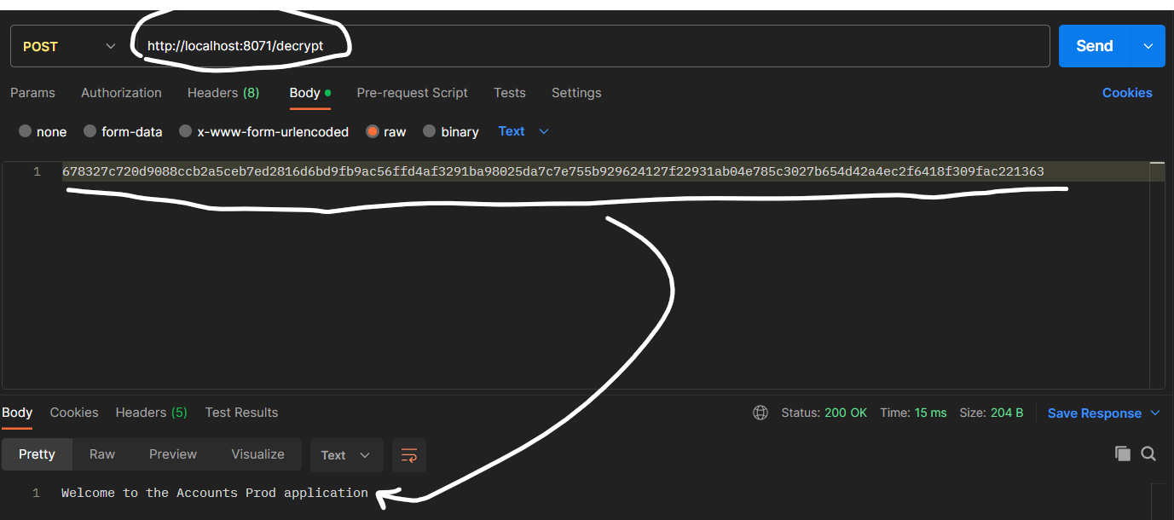 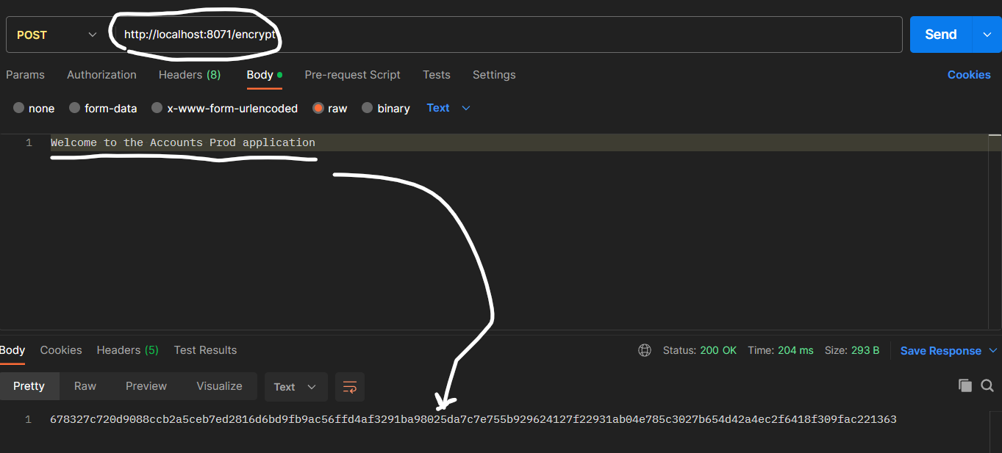

* + In *application.properties* for application, we need to add encrypted value with *{cipher} <Encrypted_Text>.*



* **Service Discovery and Registration:** Micro services have dynamic IP in network and on how each micro service should connect with each other, share information and when a new instance is created in micro service how it can be registered in the network, all these are part of Service Discovery and Registration.

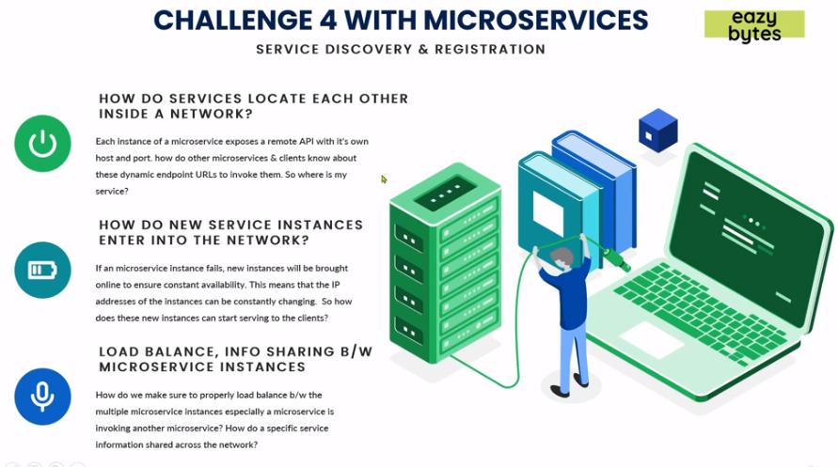

* + *Service Discovery and registrations* deals with the problems on how each micro service should connect with each other i.e., perform API calls.
  + In traditional network topology, applications have static network locations, and they can be read from a file because they rarely change, but in micro services as instances are dynamic in nature and number of instances can vary with auto scaling and failures.
  + *Micro service discovery* and *registrations* is a way for applications to locate each other in a network.
    - A central server that maintain a global view of addresses.
    - Micro service/Clients that connect to central server to register their addresses when they start and ready.
    - Micro service/Clients need to send their heartbeats at regular intervals to central server about their health.

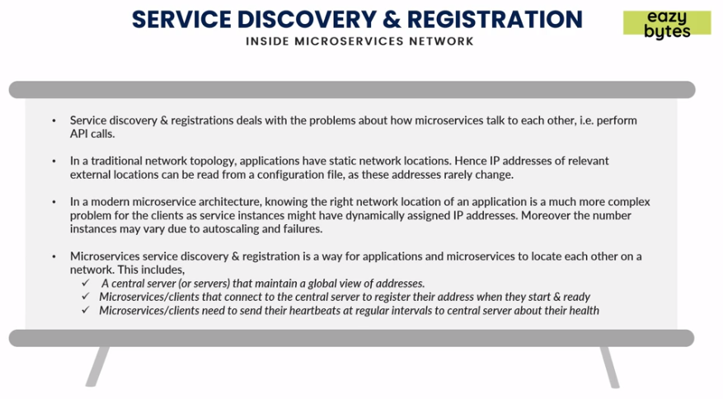

* **Traditional Load Balancers:** 
  + Traditional Load Balancers used to manage static IP address of each applications and share load between application instances using *Round Robin algorithm or Geographical location etc.* They have routing tables which stores all the IP addresses and other applications or services uses DNS to connect with backend services via load balancers.
  + But in case of micro services where there are 100s of applications and IP addresses dynamic in nature, it is hard to manage all these IP addresses inside a traditional load balancer.
  + Usually in Traditional Load balancers if primary LB fails then requests are handled by secondary LB, but if in case of micro services this will not work as 1000s of requests and load will be coming a single LB.
  + Disadvantages with traditional LB:-
    - Scaling is costly.
    - Single point of failure and centralized choke points.
    - Manually need to update IPs.
    - Not container friendly.
    - Complex in nature.

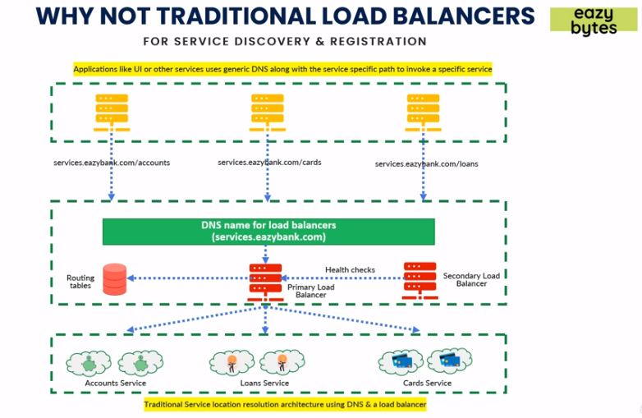

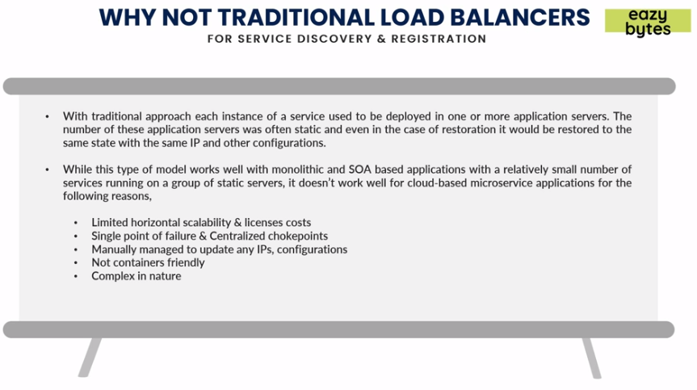

* **Architecture of Service Discovery:** 
  + In *Service Discovery* it exposes an endpoint through which the micro services can call these APIs and register themselves in Service Discovery. The values in Service Discovery is stored in forms of Key Value pairs.
  + If an instance of micro service fails to send heart beat signal in proper time or give time, Service Discovery assumes that instance is failing and removes from its internal registry.
  + *Service discovery nodes* communicate with each other internally to share details of stats of instances, new services etc.
  + Service Discovery will distribute loads amongst instances using *Round Robin algorithm* or *Geographical Location* as per defined mechanism.
  + Clients which need to connect with some micro service can go to Service discovery and connect with the micro services.

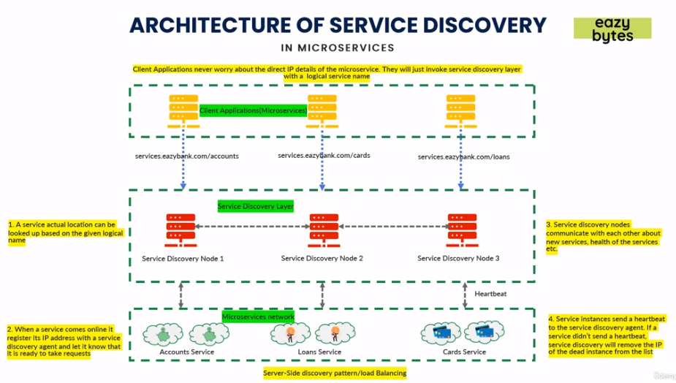

* + Advantages of Service Discovery:
    - High availability.
    - Communication between Service Discovery Agents.
    - Dynamically Manage IPs, configurations and Load balanced.
    - High fault tolerance.

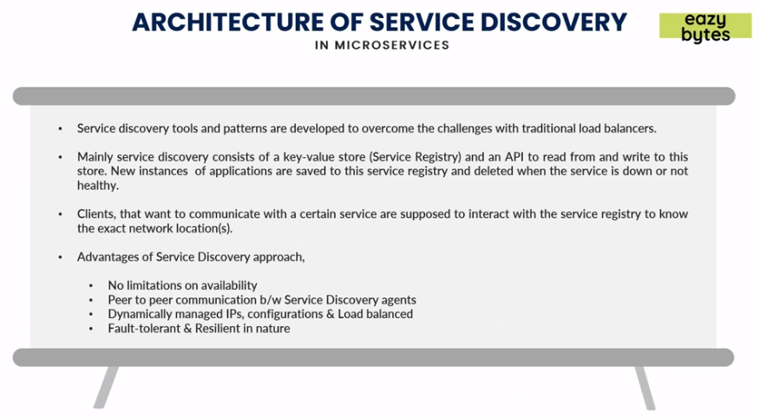

* **Client Side Load Balancing:** Efficient way of Client side load balancing is that by caching the details of IP address on first call of Service Discovery node. Let’s assume a Client application is making a call to micro service first time, it will call Service discovery then cache the network details. Now from next time it can directly make a call to that micro service since it has cached details instead of relying on Service Discovery layer. In case of new instance being created the Client side will try few times to connect with micro service and within time if it doesn’t receive it will come back to Service Discovery and cache new values of new instances and then make a call.

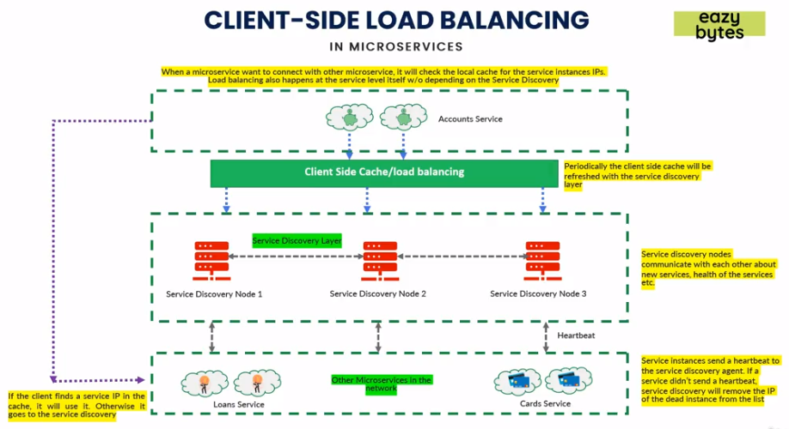

* *Spring Cloud Netflix Eureka service* will act as service discovery agent, other options are *Apache Zookeeper, etcd, Consul etc.*
* *Spring Cloud Load Balancer* for client side load balancing, other options are *Netflix Ribbon* similar to *Spring Cloud Load.*
* *Netflix Feign* client for look up amongst micro services services.

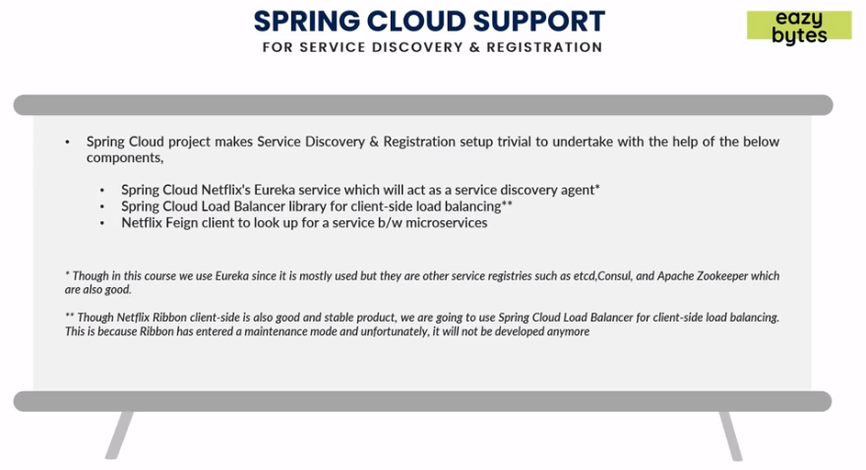

* **Creating a Eureka Service:**
  + First create a micro service with dependencies. Please note if using a Spring Boot version of >=2.5 then mentioning ribbon to the exclusions list is not required.

<dependency>

<groupId>org.springframework.cloud</groupId>

<artifactId>spring-cloud-starter-config</artifactId>

</dependency>

<dependency>

<groupId>org.springframework.cloud</groupId>

<artifactId>spring-cloud-starter-netflix-eureka-server</artifactId>

</dependency>

* + In main class of Eureka Server micro service add *@EnableEurekaServer.*

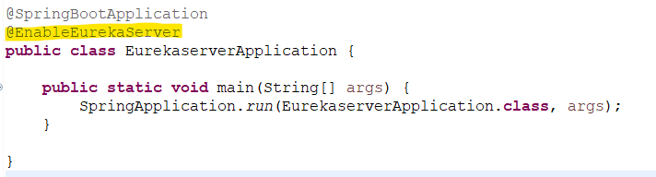

* + Add following properties in Eureka Server micro service *application.properties.*

spring.application.name=eurekaserver

#Read Eureka related properties from CMS

spring.config.import=optional:configserver:http://localhost:8071

* + In CMS add new Eureka Server properties file and add below properties.

server.port=8070

#Host of Eureka instance should be localhost

eureka.instance.hostname=localhost

#To register with Eureka server is false since this microservice itself is Eureka server

eureka.client.registerWithEureka=false

#To fetch registry from Eureka server is false since this microservice itself is Eureka server

eureka.client.fetchRegistry=false

#Connecting url for Eureka server

eureka.client.serviceUrl.defaultZone=http://${eureka.instance.hostname}:${server.port}/eureka/

* + Hit url *http://<host>:<port>/* to get Spring Eureka dashboard.

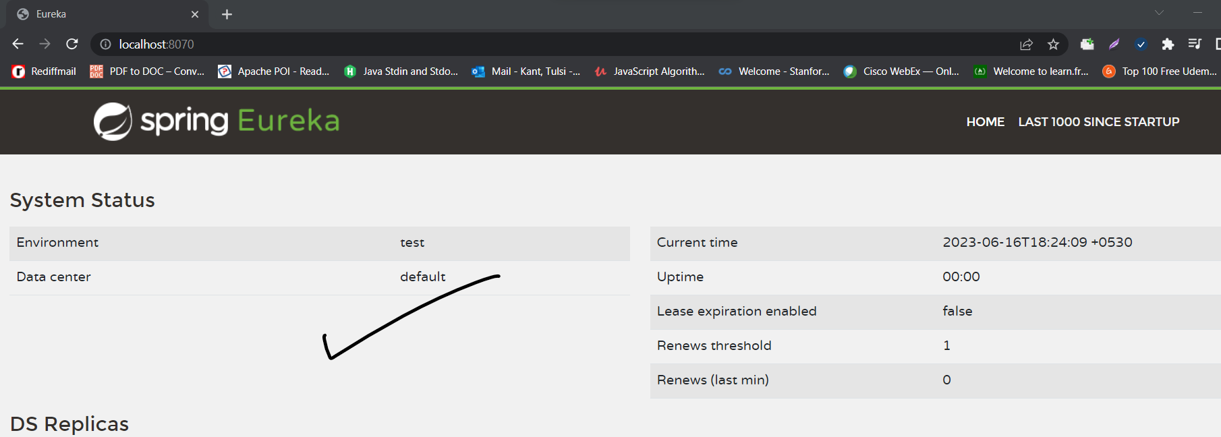

* **Registering microservices with Eureka Server:**
  + Add following dependencies in *pom.xml.*

<!--Eureka Client-->

<dependency>

<groupId>org.springframework.cloud</groupId>

<artifactId>spring-cloud-starter-netflix-eureka-client</artifactId>

</dependency>

* + Add following properties in *application.properties.*

##Eureka Server Properties

#Prefer IP to connect

eureka.instance.preferIpAddress = true

#To register with Eureka server is true

eureka.client.registerWithEureka = true

#To fetch registry from Eureka server is true

eureka.client.fetchRegistry = true

#Connecting url for Eureka server

eureka.client.serviceUrl.defaultZone = http://localhost:8070/eureka/

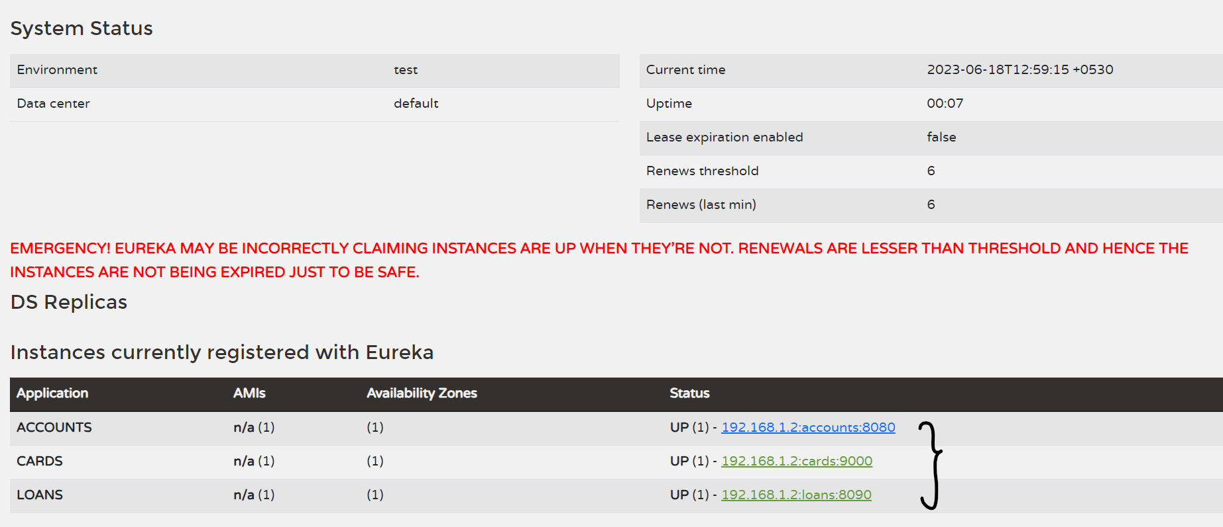

* + *http://<host>:<port>/eureka/apps/<app_name>* endpoint will provide information about instance in xml.

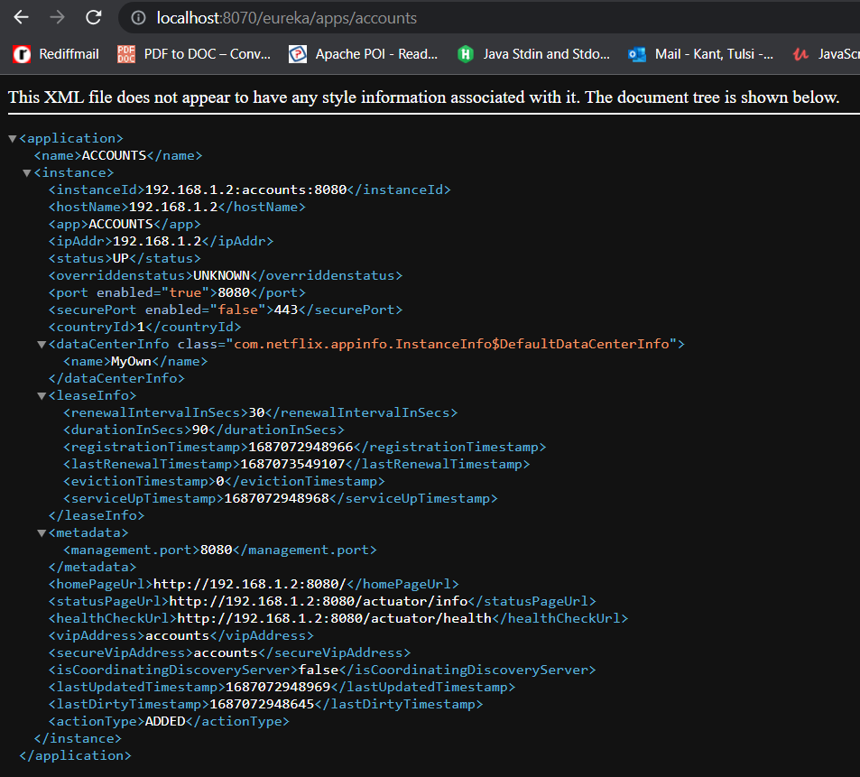 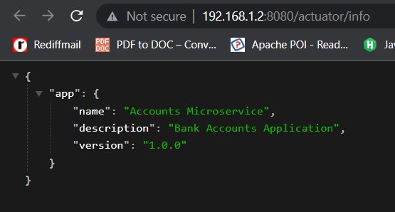

* + By default if we don’t shutdown or deregister micro services by shutdown endpoint from Eureka server, the micro service if down, Eureka will retry for some time (30sec) and then shut it down. To shutdown/de-register micro services from Eureka server need following properties in micro service properties:

#Shutdown properties

endpoints.shutdown.enabled=true

management.endpoint.shutdown.enabled=true

* + Doing a post call to shutdown endpoint : http://<Eureka_Dashboard_Endpoint>:<application_port>/actuator/shutdown

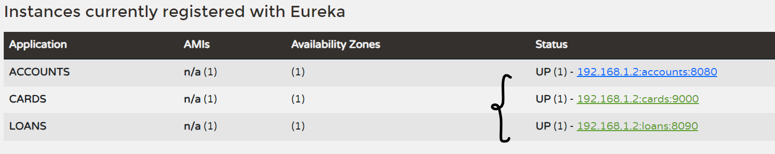 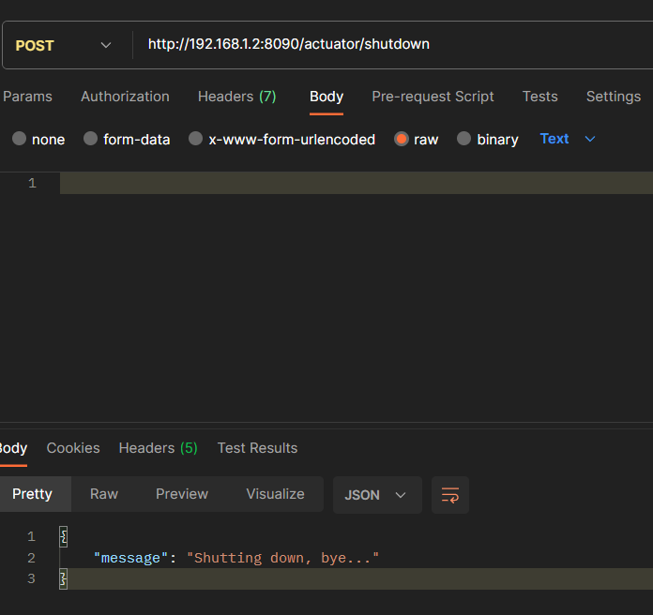

* **Feign Client:** *Feign Client* is used to communicate with other micro services without the need of hard coded links. It will auto handle the load balancing.
  + Add following dependency in *pom.xml* of micro service which needs to call other micro service.

<!--OpenFiegn Client side loadbalancing -->

<dependency>

<groupId>org.springframework.cloud</groupId>

<artifactId>spring-cloud-starter-openfeign</artifactId>

</dependency>

* + Add *@EnableFeignClients* to enable micro service to use *Feign Client* service in main class.

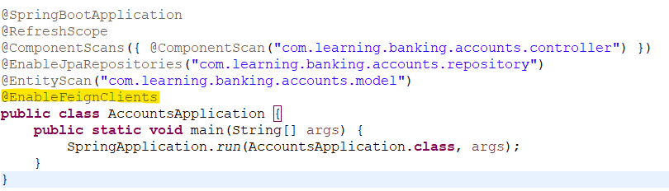

* + Add an interface with *@FeignClient(“<app_name>”)* to interact or call other micro service endpoints and map the responses in model class.

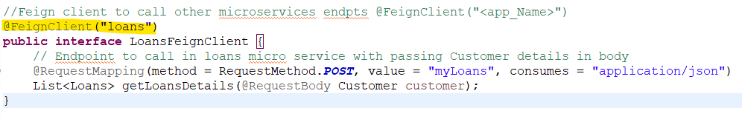

* **Eureka Self Preservation:** Generally, Eureka Server will expire the instance in let’s say 90 sec if it doesn’t receive heartbeat signal from the instance. But in case of any network failure, the Eureka will expire 15 instances out of 100 instances and will enter into self-preservation mode i.e., it will not expire any further instances from its registry.

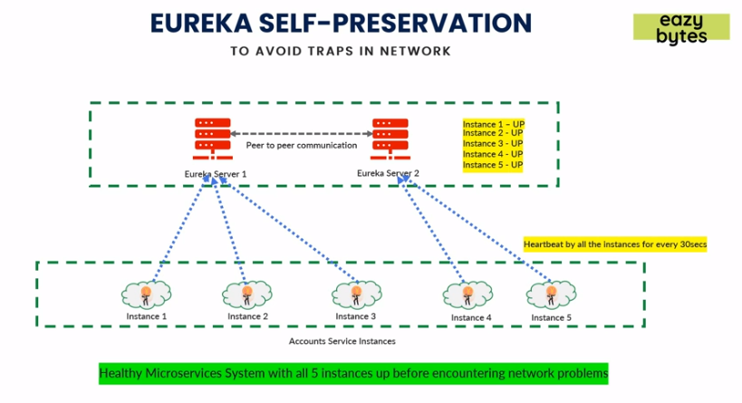

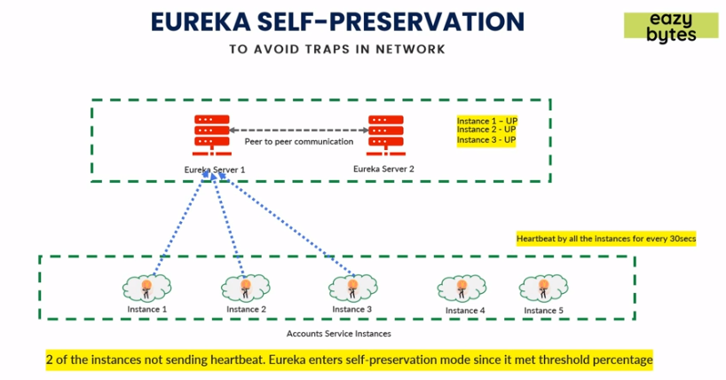

Reasons behind self-preservation mode is servers not receiving heartbeats could be due to network issue, not necessarily means that instances are down. Without self-preservation mode the registry could end up with 0 instances. Even though instances are not able to send signal to server there inter communication might be working i.e., micro service to micro service communication, so to keep them communicating self-preservation comes into picture.

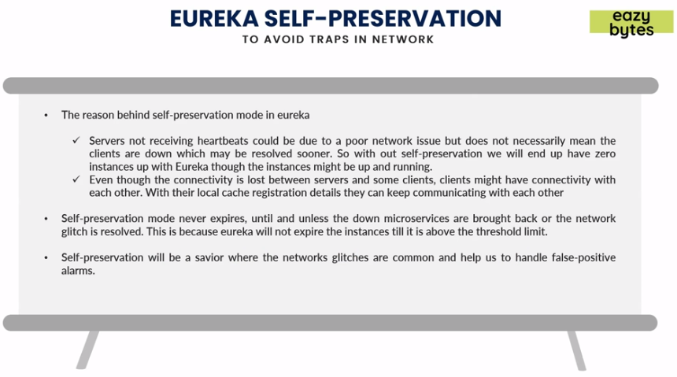

* + **Eureka server configuration for self-preservation mode:**
    - *eureka.instance.lease-renewal-interval-in-seconds=30*

Indicates the frequency the client sends heartbeats to servers to indicate that it is still alive.

* + - *eureka.instance.lease-expiration-duration-in-seconds=90*

Indicates the duration the server waits since it received the last heartbeat before it can evict an instance from its registry. This value should be greater than lease-renewal-interval-in-seconds.

* + - *eureka.server.eviction-interval-timer-in-ms=60*1000*

A scheduler is run at this frequency which will evict instances from the registry if the lease of the instances are expired as configured by lease-expiration-duration-in-seconds. Setting this value to a too large number will delay the system entering into self-preservation mode.

* + - *eureka.server.renewal-percent-threshold=0.85*

This value is used to calculate the expected heartbeats per minute.

* + - *eureka.server.renewal-threshold-update-interval-ms=15*60*1000*

A scheduler is run at this frequency which calculates the expected heartbeats per minute.

* + - *eureka.server.enable-self-preservation=true*

Self-preservation can be disabled if required.

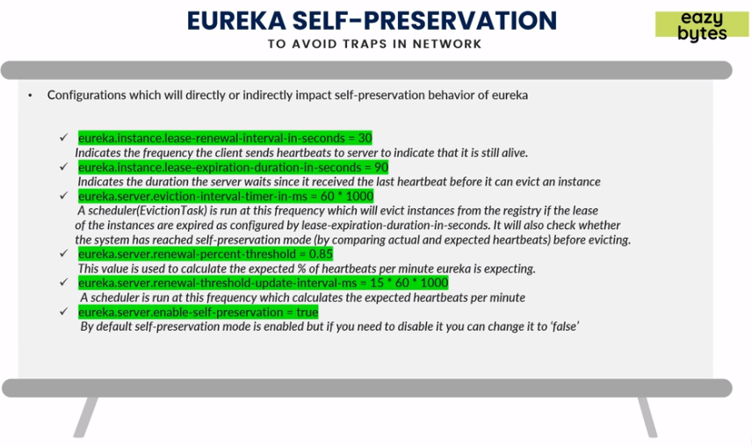

* **Resiliency in Micro service:** Capability of any micro service to recover itself in case of any failures is *Resiliency* in micro services.
  + If one micro service is not working, it should not impact other micro services or avoid cascading failures.
  + Fallback mechanism so one micro service if communicating with any failed micro service it should not fail all the system, instead have some default value to be passed on to.
  + Have some retry mechanism and provide some time to micro service to self-heal itself.

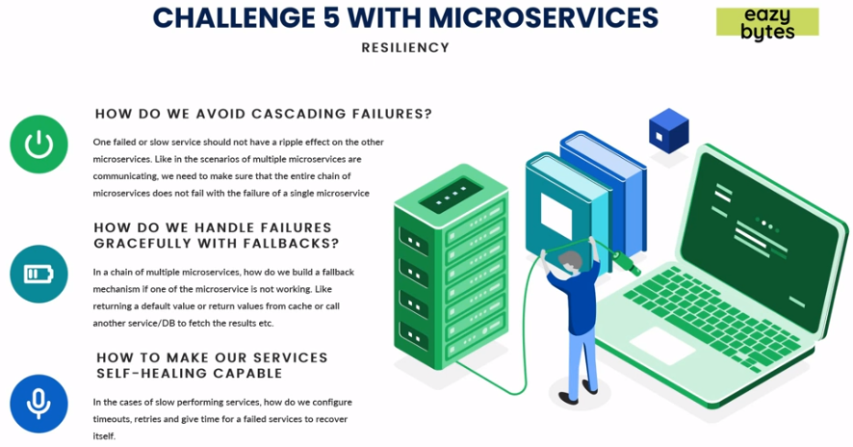

* *Resilience4j vs Netflix Hystrix:* 
  + *Resilience4j* is light weight and is designed for Java 8 and functional programming.
  + *Netflix hystrix* is heavy weight as it has other dependencies included as well like Guava and Apache Commons configuration.
  + Previously, *Hystrix* was used commonly to provide resiliency in micro services but no new features are developed anymore hence everyone uses *Resilience4j,* which has more feature than *Hystrix.*
  + *Resilience* offers features or core modules like:
    - *Circuit breaker:* Used to stop making requests when a service is failing.
    - *Fallback:* Alternative route for failing requests.
    - *Retry:* Retries when a service is failing.
    - *Rate Limit:* Limits the number of calls to a service in a time.
    - *Bulkhead:* Limits the number of outgoing requests to a service to avoid overloading.

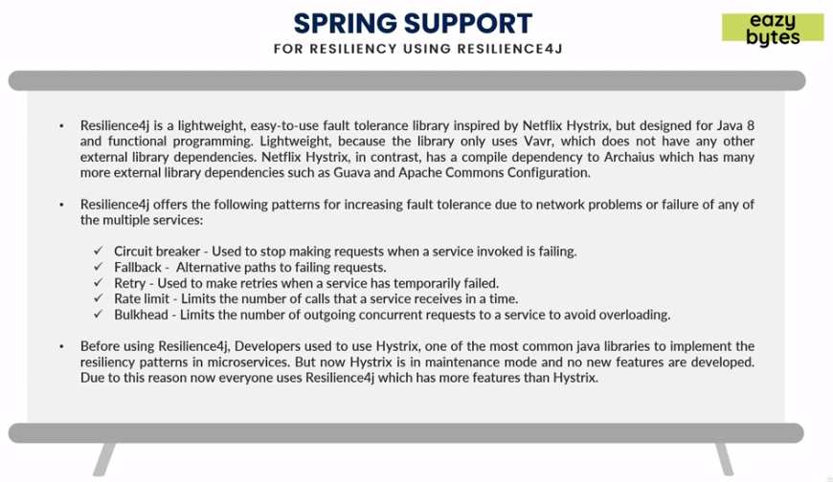

* **Circuit Breaker Pattern:** In a typical scenario App1 is need information from all services, App2 needs information from Accounts service, App3 needs information from Loans service and App4 is failing which is cards service.

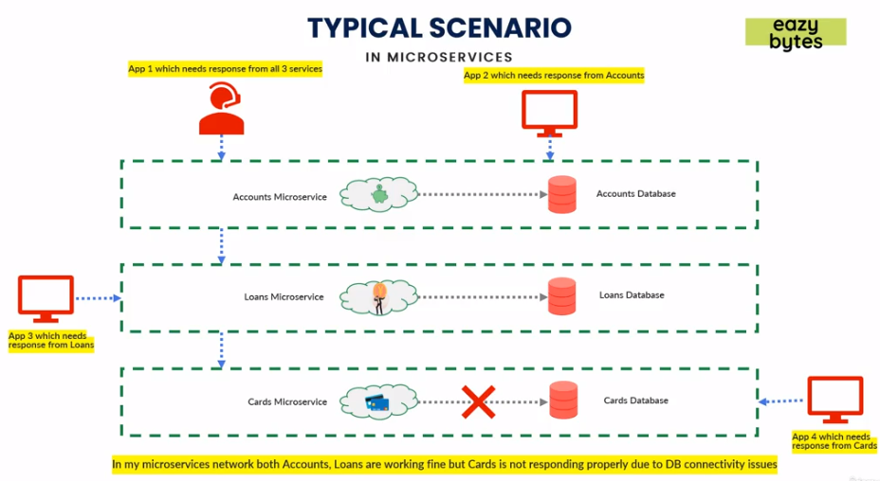

In Circuit breaker pattern, whenever a call is taking is taking too much time, the circuit breaker will cut the call. The circuit breaker will monitor all the calls and if enough call fails, it will open the network preventing further calls coming to fail. If issue resolves in some time, circuit breaker will detect for the fault if resolved or not, If yes then it applications try invoking calls again.

* **Advantages:**
  + Fail fast so other micro service doesn’t depend on failed service and take much time.
  + Fail gracefully.
  + Recover seamlessly.

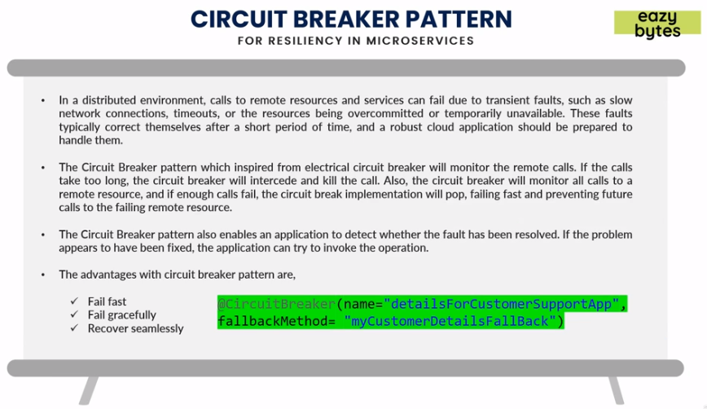

* **Stages of circuit breaker pattern:**
  + *Closed:* All calls will happen and let all client calls happen.
  + *Open:* If the requests fail beyond threshold, it will open circuit so all calls fails fast.
  + *Half-Open:* At a periodic interval, circuit breaker will check if issue resolved or not.Based on result it will go into Open or Closed state.

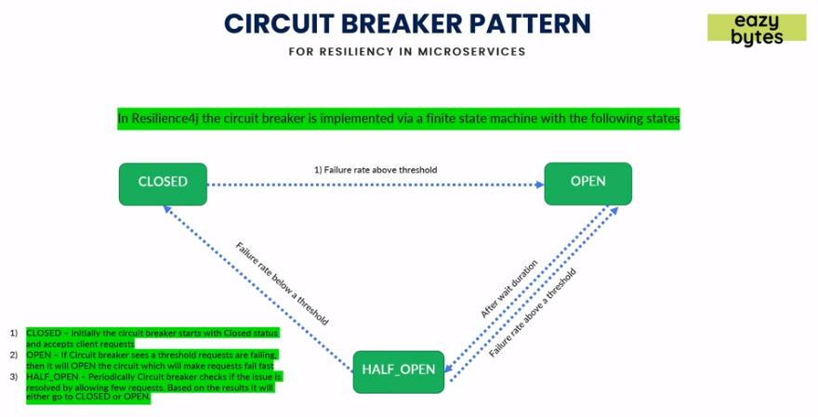

* In below diagram in scenario 1 there is no circuit breaker and all calls will fail to cards service and calls will get slower. In scenario 2 there is circuit breaker pattern implemented so the calls will fail fast and in scenario 3 we have implemented some failback mechanism so instead of error provide some alternative business logic or some cached values.

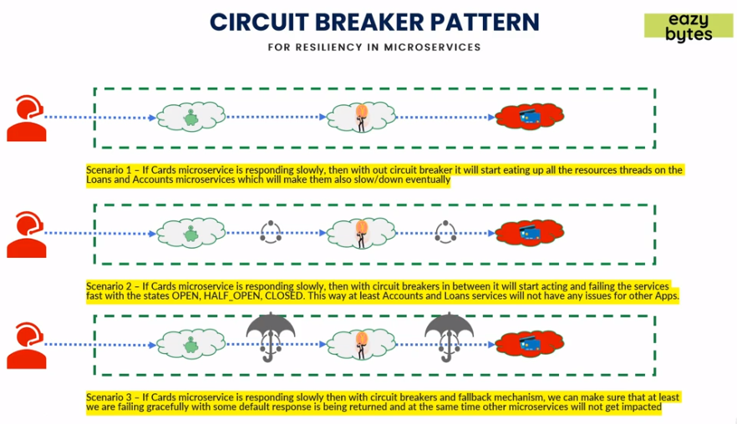

* **Implementing circuit breaker pattern:** 
  + **Dependencies:** Add below dependencies in application *pom.xml.*

<!--Resilience4j dependency-->

<dependency>

<groupId>io.github.resilience4j</groupId>

<artifactId>resilience4j-spring-boot2</artifactId>

</dependency>

<!--Resilience4j circuit breaker depenedency-->

<dependency>

<groupId>io.github.resilience4j</groupId>

<artifactId>resilience4j-circuitbreaker</artifactId>

</dependency>

<!--Resilience4j can use spring AOP-->

<dependency>

<groupId>org.springframework.boot</groupId>

<artifactId>spring-boot-starter-aop</artifactId>

</dependency>

* + **Properties:** Add below properties in *application.properties*.

##Resilience4j properties

##Circuit Breaker Pattern properties

#asking Resilience4j to register for health check for each circuit breaker as true

resilience4j.circuitbreaker.configs.default.registerHealthIndicator= true

#monitor minimum number of calls to fail so circuit breaker close or open (resilience4j.circuitbreaker.instances.<circuit breaker name>.minimumNumberOfCalls)

resilience4j.circuitbreaker.instances.detailsForCustomerSupportApp.minimumNumberOfCalls= 5

#minimum threshold for failure is 50%

resilience4j.circuitbreaker.instances.detailsForCustomerSupportApp.failureRateThreshold= 50

#wait duration before opening the circuit

resilience4j.circuitbreaker.instances.detailsForCustomerSupportApp.waitDurationInOpenState= 30000

#circuit breaker allows 2 calls in half open state if fails go back to open/close again

resilience4j.circuitbreaker.instances.detailsForCustomerSupportApp.permittedNumberOfCallsInHalfOpenState=2

* + Add *@CircuitBreaker(name=””* *, fallbackMethod= "”)* to enable circuit breaker in controller method.

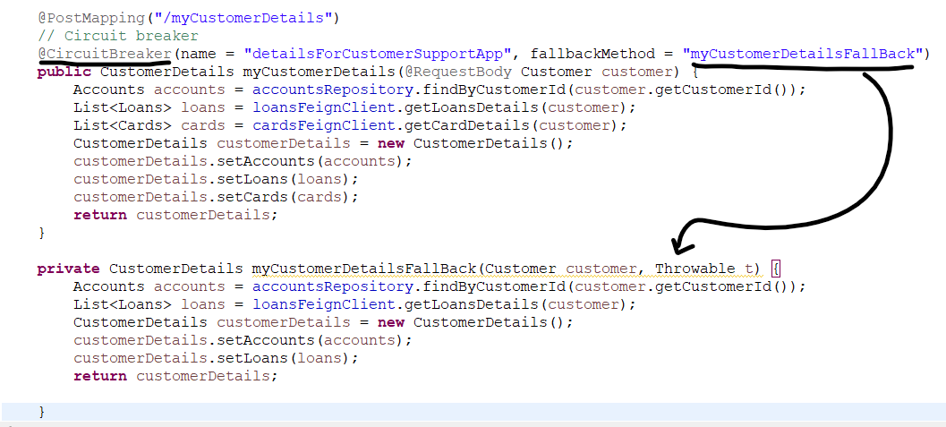 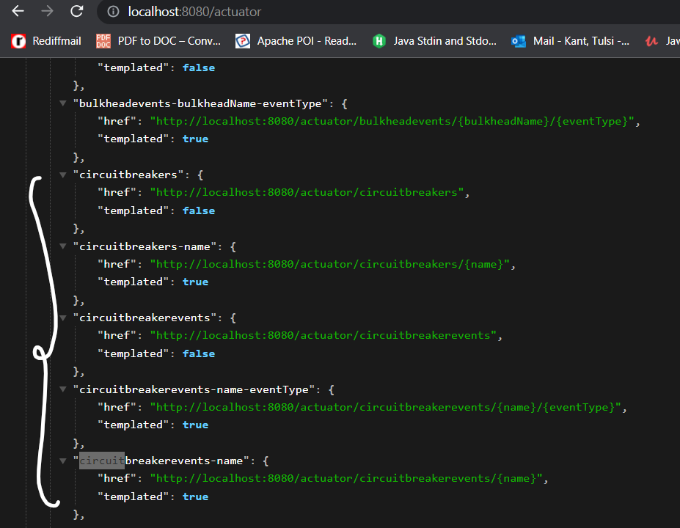

* + Error after 5 calls.

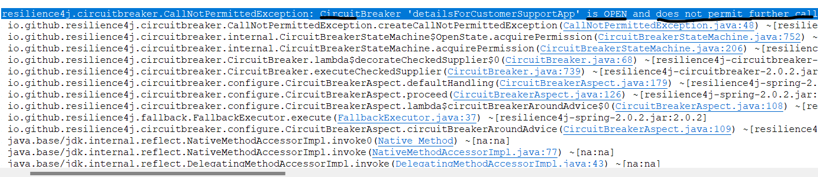

* **Retry Pattern:** In case of calls failing it will retry the calls again.
  + It has attributes:
    - *maxAttempts* *🡪* Max number of attempts.
    - *waitDuration 🡪* A fixed duration before next retry*.*
    - *retryException 🡪* Configure list of Throwable classes that are recorded as failure and are retrieved.
    - *ignoreExceptions 🡪* Configure list of Throwable classes that are recorded as failure and are not retrieved.

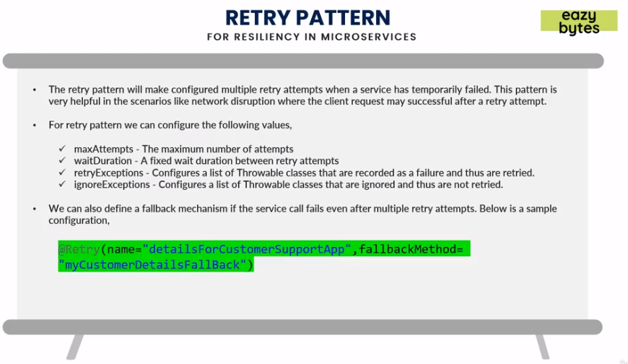

* **Implementing Retry pattern:**
  + Add following properties in *application.properties.*

##Retry Pattern properties

#asking Resilience4j to register for health check for retry as true

resilience4j.retry.configs.default.registerHealthIndicator= true

#max number of retries allowed

resilience4j.retry.instances.retryForCustomerDetails.maxRetryAttempts=3

#Wait duration before each retry

resilience4j.retry.instances.retryForCustomerDetails.waitDuration=2000

* + Add *@Retry(name=””, fallbackMethod=””)* to enable retries in calls.

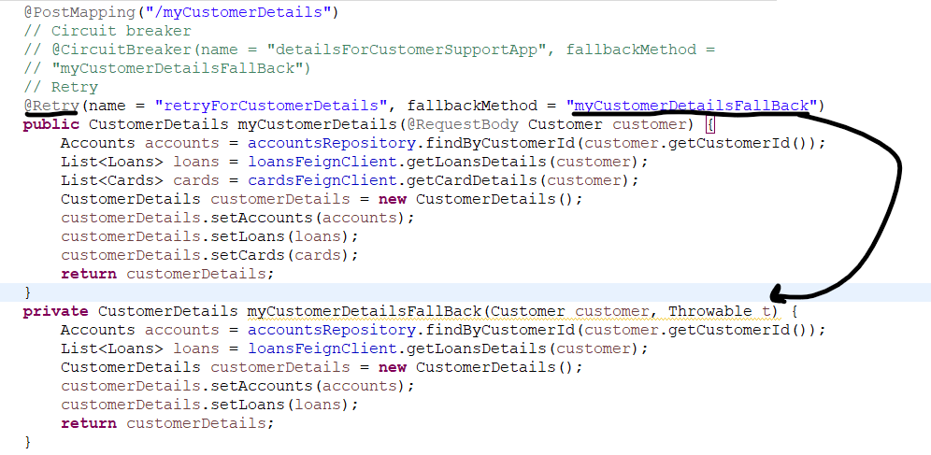

* **Rate Limiter:** *Rate Limiter* pattern will help to stop overloading more calls to a service, than it consumes in a time.
  + It has attributes:
    - *timeoutDuration* *🡪* Max wait time for threads.
    - *limitForPeriod 🡪* Number of calls during refresh period.
    - *limitRefreshPeriod 🡪* Limit refresh period.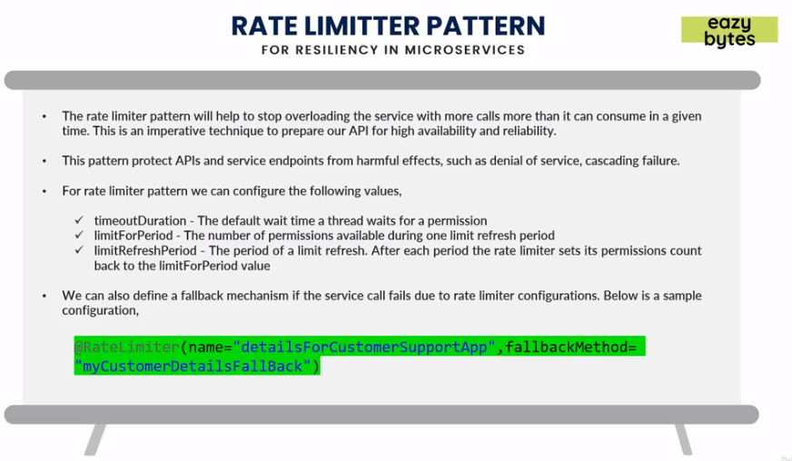
* **Implementing Rate Limiter:**
  + Add following dependency in *pom.xml* along with *Resilience4j.*

<!--Resilience4j rate limiter depenedency-->

<dependency>

<groupId>io.github.resilience4j</groupId>

<artifactId>resilience4j-timelimiter</artifactId>

</dependency>

* + Add following properties in *application.properties.*

##Rate Limiter properties

#asking Resilience4j to register for health check endpt in actuator for retry as true

resilience4j.ratelimiter.configs.default.registerHealthIndicator= true

#Max wait duration to invoke rate limiter

resilience4j.ratelimiter.instances.sayHello.timeoutDuration=5000

#Refresh period for rate limiter

resilience4j.ratelimiter.instances.sayHello.limitRefreshPeriod=5000

#Max number of calls to wait before invoking rate limiter

resilience4j.ratelimiter.instances.sayHello.limitForPeriod=1

* + Add *@RateLimiter(name=””, fallbackMethod=””)*

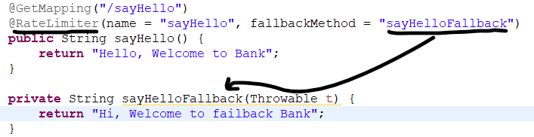

* **Bulk Head Pattern:** *Bulk Head Pattern* will help to allocate and limit the resources which can be used for specific services. So that resource exhaustion can be reduced. It is way in which certain APIs inside a service can be isolated so no single API call consumes most of the resources like threads etc.

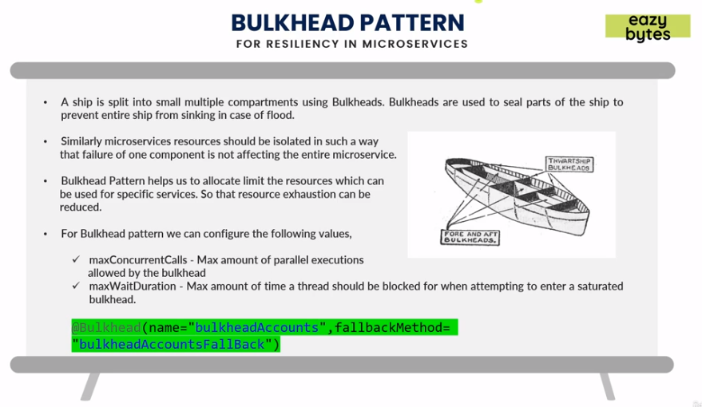

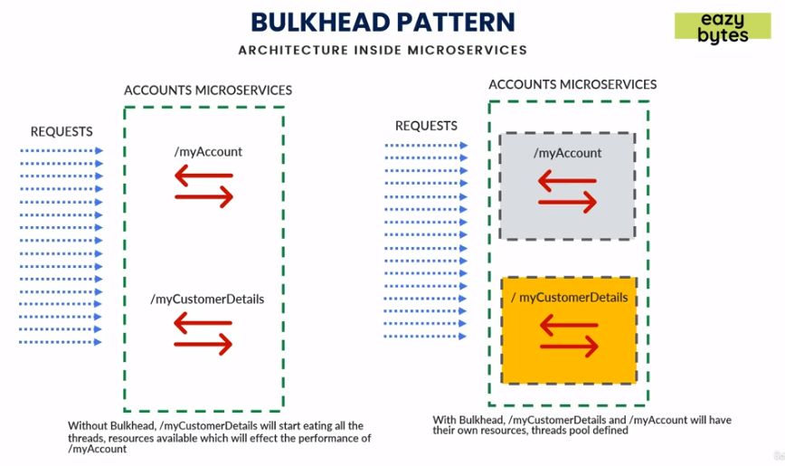

* **Routing and Cross cutting concerns:** *Cross cutting concerns* means challenges like logging, auditing, monitoring that micro services can have. Keeping a single Gatekeeper so all incoming requests go from single path following policies for all service calls.

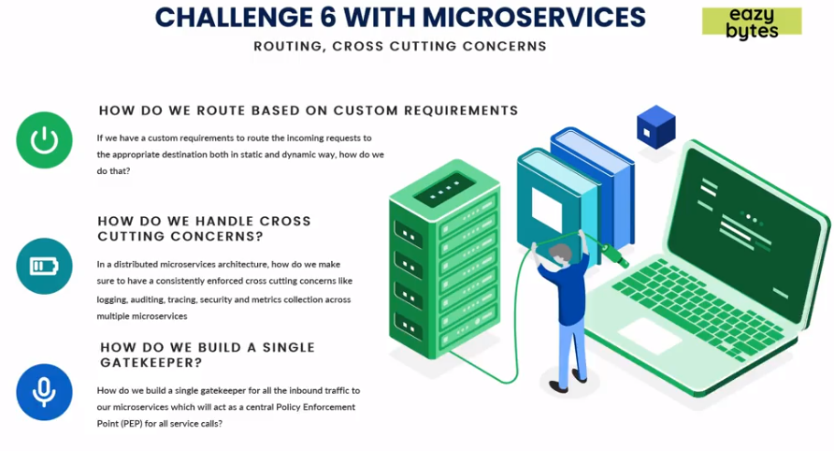

* **Spring Cloud Gateway:** It is library for building API gateway. It sits between client and the resource which is being requested, intercepts, analyzes and modifies every request before sending from client to the service. *Spring Cloud Gateway* is replacement for *Zuul* due to performance issues, as it is built by the Spring Cloud team and is non-blocking in nature. *Spring Cloud Gateway* is superior in terms of performance with *Zuul*.

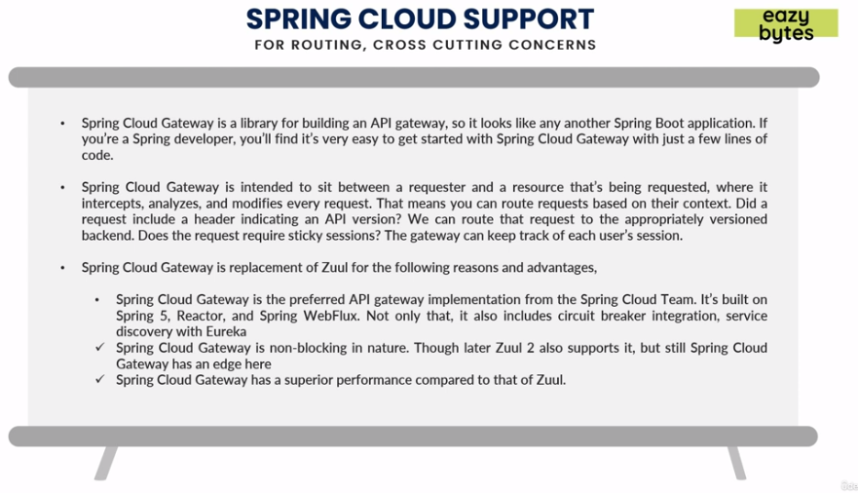

* **Architecture of Spring Cloud Gateway:** Whenever a request comes from client to *Spring Cloud Gateway*, the *Gateway handler* first checks the request if it matches with the route. *Predicates* in *Spring Cloud Gateway* can be used to check for request matching. It request is matched it will send the request to the pre-filters, then the request is forwarded to the post-filters which then will forward requests to the actual Eureka server or micro services.

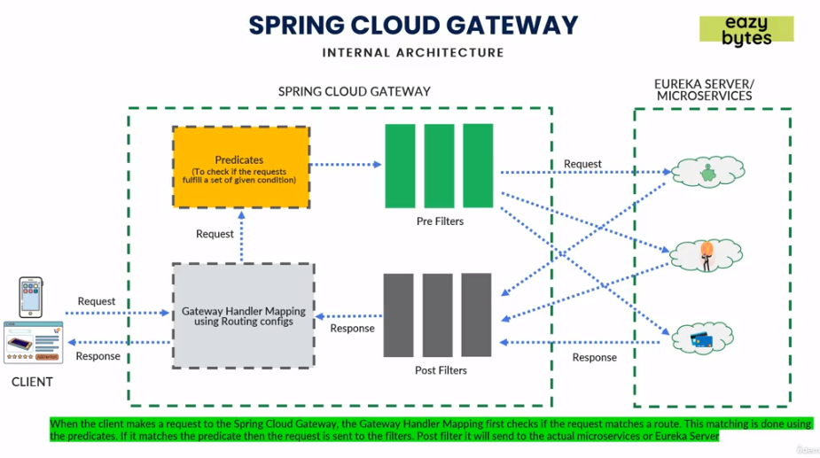

Spring Gateway cloud handles security, adding header information, verifying requests etc for each calls so micro services don’t need to handle it that their own level. Spring Cloud Gateway acts as a gatekeeper for all inbound traffic to micro service calls and acts as a central Policy Enforcement Point (PEP) inside micro services architecture.

* **Setting up Spring Cloud Gateway:** 
  + Add following dependency in *pom.xml* of gatewayserver application.

<dependency>

<groupId>org.springframework.cloud</groupId>

<artifactId>spring-cloud-starter-gateway</artifactId>

</dependency>

* + Add following properties in the gatewayserver *application.properties.*

management.info.env.enabled = true

management.endpoint.gateway.enabled=true

#Connect with Eureka server discovery and get all services

spring.cloud.gateway.discovery.locator.enabled=true

#Connect with Eureka server discovery and get all services in lowercase

spring.cloud.gateway.discovery.locator.lowerCaseServiceId=true

* + Add below properties in configserver.

eureka.instance.preferIpAddress = true

#Register with Eureka registry

eureka.client.registerWithEureka = true

#Fetch IPs from Eureka Registry

eureka.client.fetchRegistry = true

#Eureka URL

eureka.client.serviceUrl.defaultZone = http://localhost:8070/eureka/

* + A gateway endpoint will be exposed in the actuator url. Add /*routes* to the gateway url routes. Predicate by default will filter the requests by name *“/accounts”* and will redirect to accounts micro service in this case. We can call accounts micro service from gateway server url as well like in this case *http://localhost:8072/accounts/myaccount*

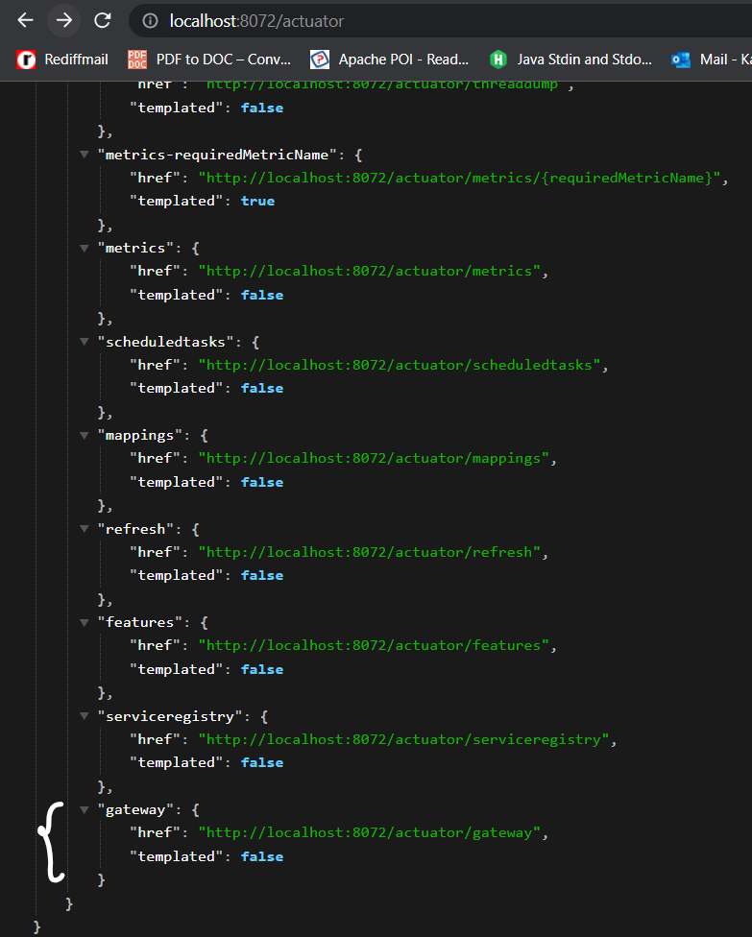 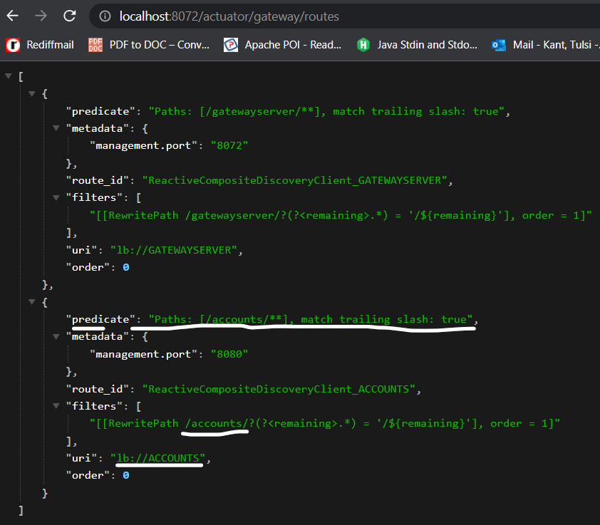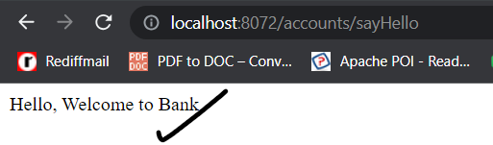

* **Distributed Tracing and Log aggregation:** *Distributed tracing and log aggregation* means that from different micro services and paths logs generated should be kept in single place so that to search, filter and index logs becomes easy, also to monitor the stats of each calls like duration etc from chain of service calls.

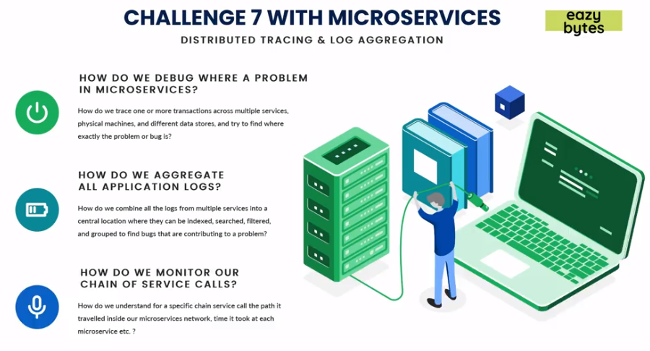

* **Spring Cloud Sleuth and Zipkin:** 
  + *Spring Cloud Sleuth:*
    - Spring auto configuration for distributed tracing.
    - It adds trace and span ids to all logs.
    - It does by adding the filters, interacting with Spring components to let correlation Id being passed through system calls.
  + *Zipkin:* 
    - It is an open source data visualization tool that helps in aggregating all logs or gathering them in a single place so that it can be analyzed or traced.
    - It breaks each transactions into components and visually identify where there is performance issues.

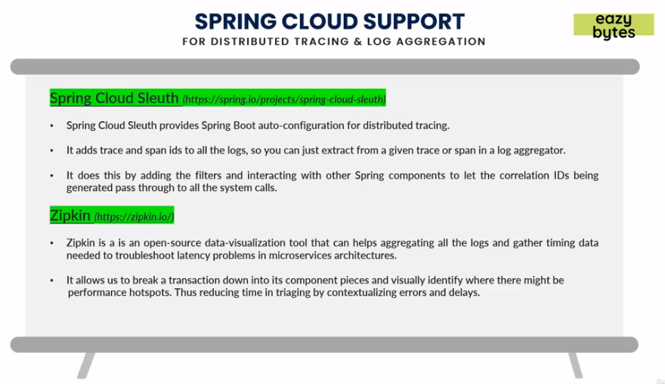

* **Spring Cloud Sleuth:** It will have 3 components *(<App_Name>.<TraceId>.<SpanId>)*:
  + *Application Name:* Name of the application. *Spring Cloud Sleuth* gets name of application from property ‘*spring.application.name*’.
  + *Trace Id:* It is a unique alpha numeric number that represents an entire transaction.
  + *Span Id:* It is a unique alpha numeric number that represents part of an overall entire transaction. Each micro service will have its own *Span Id*.

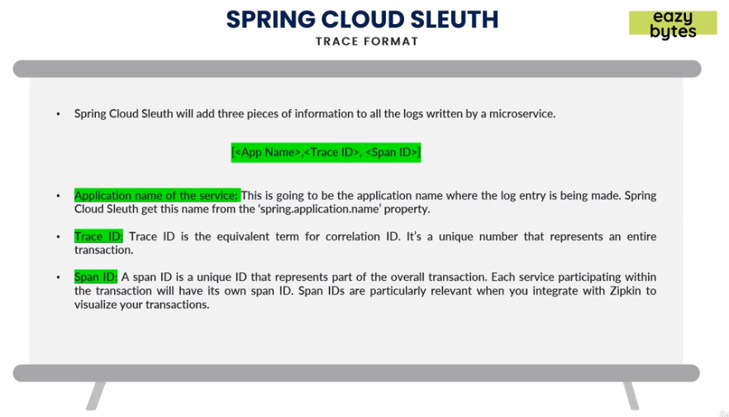

The below diagram shows an example of *Spring Cloud Sleuth* generating 3 components at different service calls or levels.

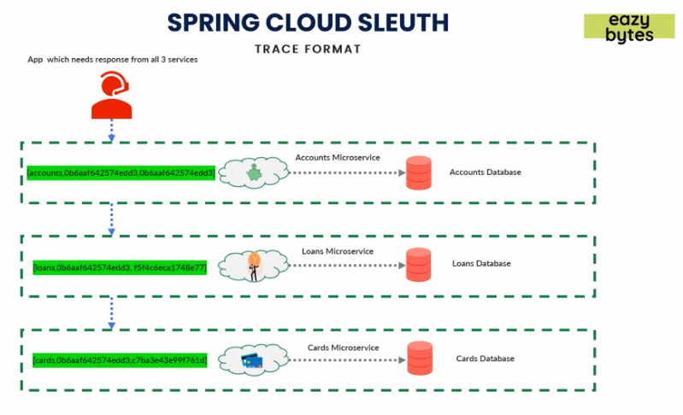

* **Zipkin:** There are two ways to send data to *Zipkin,* Synchronous (via Web/http) or Asynchronous (Rabbit, Active MQ or ELK). It has 4 components:
  + *Collector:* Once the trace data arrives at the *Zipkin Collector daemon.* It is validated, stored and indexed for lookups by *Zipkin Collector.*
  + *Storage: Zipkin* supports in-memory, MySQL, Cassandra and Elastic search for storing logs, tracing and information.
  + *Zipkin Query Service API:* Query daemon provides a simple JSON API for finding and retrieving traces once data is stored and indexed and is consumed by *Zipkin Web UI.*
  + *Web UI:*  It provides a method for viewing traces based on service, time and annotations.

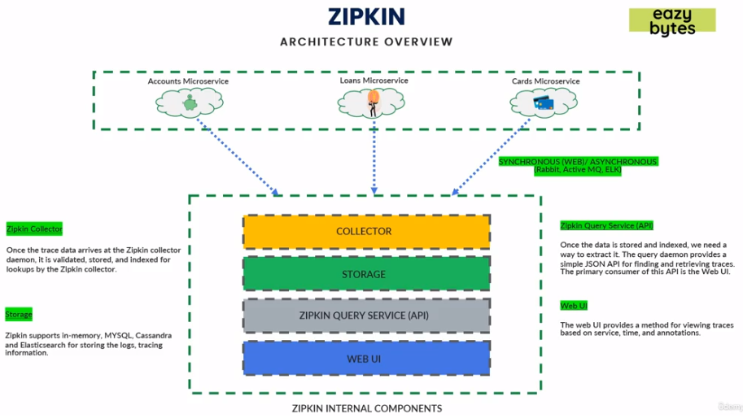

* **Implementing Distributed tracing using Spring Cloud Sleuth:** 
  + Note this will work only if we are using Spring Cloud version which is less than 2022.0.0 and logging in classes or methods where we want to add tracing.

<dependency>

<groupId>org.springframework.cloud</groupId>

<artifactId>spring-cloud-starter-sleuth</artifactId>

</dependency>

From Spring Cloud 2022.0.0 & Spring Boot 3, the Sleuth project has been removed & the core of this project has moved to Micrometer Tracing.

<dependency>

<groupId>io.github.openfeign</groupId>

<artifactId>feign-micrometer</artifactId>

</dependency>

<dependency>

<groupId>io.micrometer</groupId>

<artifactId>micrometer-registry-prometheus</artifactId>

</dependency>

<dependency>

<groupId>io.micrometer</groupId>

<artifactId>micrometer-tracing-bridge-otel</artifactId>

</dependency>

* + Add following properties in all micro services *application.properties.*

# Micrometer related properties

management.tracing.sampling.probability=1.0

management.zipkin.tracing.endpoint=http://localhost:9411/api/v2/spans

management.metrics.distribution.percentiles-histogram.http.server.requests=true

logging.pattern.level=%5p [${spring.application.name:},%X{traceId:-},%X{spanId:-}]

* + Add below class in GateWayServer project*. ObservationContextSnapshotLifter,* it is a custom filter which is inside the same project under *"com.learning.gatewayserver.logging"* package. It has various methods implemented like *onNext(T t), onSubscribe()* etc. which helps in delegating the context details like trace ids to next microservices in the network.



* **Implementing Zipkin UI:** 
  + Go to <https://zipkin.io/pages/quickstart.html> and copy command for running *Zipkin* Docker image. *docker run -d -p 9411:9411 openzipkin/zipkin*
  + Once Docker image is pulled, *Zipkin* link exposed at: <http://localhost:9411/zipkin/>.

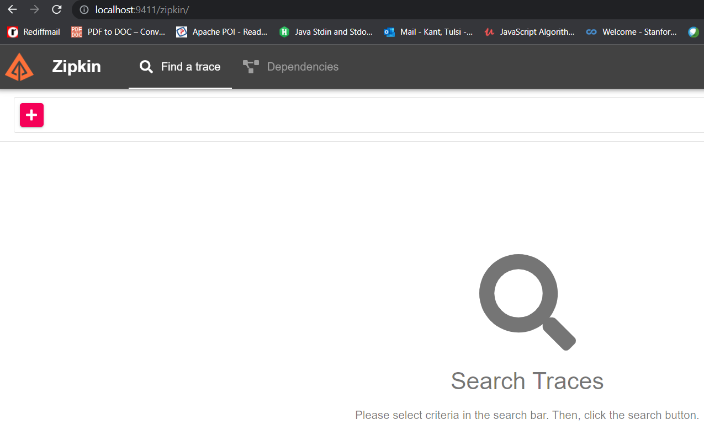

* + Add following dependencies in all *pom.xml* if using *Spring Cloud Sleuth.*

<dependency>

<groupId>org.springframework.cloud</groupId>

<artifactId>spring-cloud-sleuth-zipkin</artifactId>

</dependency>

Otherwise, if using *micrometer*, then add below required dependency of *Zipkin*

<dependency>

<groupId>io.opentelemetry</groupId>

<artifactId>opentelemetry-exporter-zipkin</artifactId>

</dependency>

* + Add following properties in all micro services *application.properties.*

# Micrometer related properties

#100% means all transactions will be logged in Zipkin, .5 means

management.tracing.sampling.probability=1.0

#Zipkin URL

management.zipkin.tracing.endpoint=http://localhost:9411/api/v2/spans

* + In the *Zipkin dashboard* we can see all calls trace or hierarchy along with dependencies and response times.

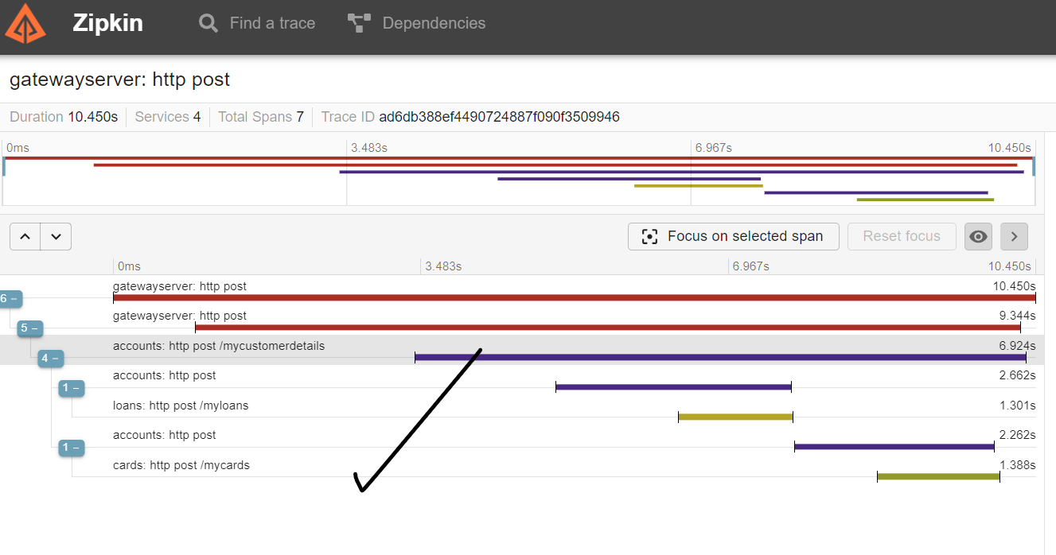

* **Implementing Log aggregation using Asynchronous method using Rabbit MQ:** 
  + Benefits of pushing *Sleuth* messages to Asynchronous like Rabbit MQ etc is that it improves performance as once message pushed micro service will not need to wait for response.
  + Add following dependencies in *pom.xml,* Note that this will work only with *Sleuth*. In case if using *micrometer*, it doesn't support pushing loggers into Rabbit MQ asynchronously as of now.

<dependency>

<groupId>org.springframework.amqp</groupId>

<artifactId>spring-rabbit</artifactId>

</dependency>

* + Run the docker command *'docker run -it --rm --name rabbitmq -p 5672:5672 -p 15672:15672 rabbitmq:3-management'*. This docker command will start the Rabbit MQ related docker container using the provided docker image. Note *15672* is *Web UI* port whereas *5672* is *management* port for *Rabbit MQ*.

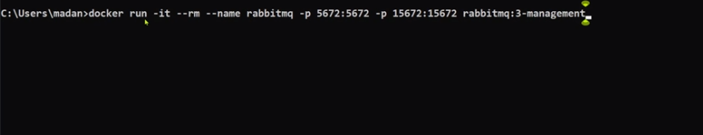

* + To validate if the Rabbit MQ server started successfully or not, visit the URL *http://localhost:15672* and login with *username/password* as *guest.*
  + Add following properties in all micro services *application.properties.*

##Rabbit MQ properties

#By default its web for synchronous but in this case its Rabbit MQ asynchronous

spring.zipkin.sender.type=rabbit

#Name of the queue to which sleuth message will be sent in Rabbit MQ

spring.zipkin.rabbitmq.queue=zipkin

#Server of Rabbit MQ

spring.rabbitmq.host=localhost

#15672 is WebUI port whereas 5672 is management port for Rabbit MQ

spring.rabbitmq.port=5672

#Credentials for Rabbit MQ login

spring.rabbitmq.username=guest

spring.rabbitmq.password=guest

* + In *Rabbit MQ* console we can see the *Sleuth Messages* in *zipkin* queue.

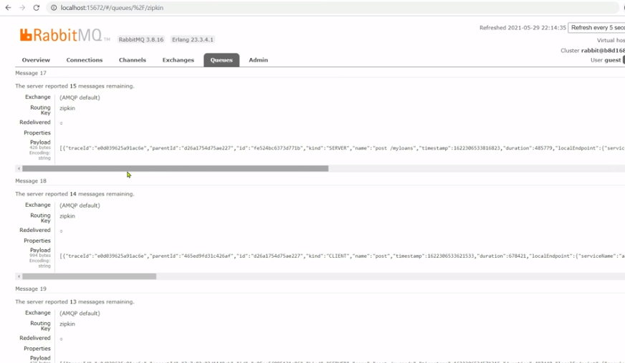

* **Sample Docker Compose Yaml with Micro meter and Sleuth:**

